Measuring the health benefits, costs, and cost-effectiveness of antimicrobial-resistant gonorrhea surveillance in the United States

Authors:
Ekanayake-Weber, MS^{1,2,3,4}
Rönn, MM⁵
Yin, X⁶
Hsu, K⁷
Li, Y⁵
Gift, TL⁸
Chesson, H⁸
Frankson, R⁸
Salomon, JA⁹
Grad, YH¹⁰
Yaesoubi, R^{2,3,11}
- Department of Anthropology, University at Albany, Albany NY 12222
- Department of Health Policy and Management, Yale School of Public Health, New Haven CT 06511
- Public Health Modeling Unit, Yale School of Public Health, New Haven CT 06511
- Department of Anthropology, Stony Brook University, Stony Brook NY 11794
- Department of Global Health and Population, Harvard T.H. Chan School of Public Health, Harvard University, Boston, MA 02115
- Department of Management Science and Information Systems, Spears School of Business, Oklahoma State University, Stillwater, OK 74078
- Massachusetts Department of Public Health, Boston, MA 02108
- Centers for Disease Control and Prevention, Division of STD Prevention, Atlanta, GA 30329
- Department of Health Policy, Stanford University School of Medicine, Stanford, CA 94305
- Department of Immunology and Infectious Diseases, Harvard T.H. Chan School of Public Health, Harvard University, Boston, MA 02115
- Department of Epidemiology and Biostatistics, University of California, San Francisco, San Francisco CA 94158
Keywords: agent-based model, sexually transmitted infection, MSM, antimicrobial resistance, Neisseria gonorrhoeae
The findings and conclusions in this report are those of the authors and do not necessarily represent the official position of the Centers for Disease Control and Prevention.

Abstract

Background
Antimicrobial-resistant (AMR) gonorrhea poses an increasing threat to public health, yet evidence on the cost-effectiveness of surveillance systems that inform treatment policy is lacking. We assessed the long-term, population-level health benefits, costs, and cost-effectiveness of the Gonococcal Isolate Surveillance Project (GISP), the US national surveillance system for AMR gonorrhea.

Methods
We developed an agent-based model of gonococcal transmission among men who have sex with men to project gonorrhea-associated costs (healthcare sector perspective) and quality-adjusted life-years (QALYs) lost under GISP and three hypothetical scenarios in the absence of GISP: randomized treatment, test-of-cure, and a combination strategy, representing a combination of clinical strategies for treating gonorrhea.

Findings
Over 20 years in a population of 100,000 men who have sex with men, all strategies resulted in similar overall gonorrhea incidence, but GISP achieved the lowest treatment failure rate (0·6% vs 8%, 16%, and 11%) and lowest AMR gonorrhea incidence (28,756 vs 99,273, 155,983, and 120,252 cases). GISP resulted in similar costs and QALYs compared with randomized treatment, but lower costs and greater QALYs compared to the test-of-cure or combination strategies.

Interpretation
Our findings highlight the health and economic benefits of GISP in controlling AMR gonorrhea and support investment the national surveillance system of AMR gonorrhea in the US. Additional studies are required to investigate the generalizability of our findings for other countries.

Funding
National Institutes of Health.

Research In Context

Evidence before this study
Neisseria gonorrhoeae has developed resistance to all first-line antibiotics used to treat it. In the United States, the empiric treatment of gonorrhea is determined based on the data provided by the Gonococcal Isolate Surveillance Project (GISP), an ongoing sentinel surveillance system to monitor trends in antimicrobial-resistant (AMR) gonorrhea. Despite the important role GISP plays in ensuring that patients with gonorrhea receive effective treatment, no evidence exists about its population's health impact and cost-effectiveness. We searched PubMed for articles published in the indexed literature up to Nov 18th, 2025 (the date of our search), using the following terms: ((gonorrhea) OR (gonococcal)) AND (surveillance) AND (resistan*) AND ((model* OR cost-effectiveness)). We found 152 studies, of which 19 assessed the impact of AMR gonorrhea surveillance programs. None focused on evaluating the cost-effectiveness of GISP compared to counterfactual strategies without GISP.

Added value of the study
To our knowledge, this study is the first to assess the population health impact and cost-effectiveness of GISP. Using an agent-based dynamic transmission model of gonorrhea for men who have sex with men (MSM) in the US, we compared the health and cost outcomes under GISP and several counterfactual scenarios wherein clinical management strategies were used to ensure the effective treatment of gonorrhea in the absence of GISP, including randomized treatment, test-of-cure, and a combination of randomized treatment and test-of-cure. We found that GISP, along with other counterfactual strategies considered here, led to a similar gonorrhea incidence rate. However, GISP resulted in the lowest treatment failure rate and the incidence of AMR cases. Compared to strategies considered here, GISP was demonstrated to be cost-effective under various scenarios.

Implications of all the available evidence
Our study demonstrates the effectiveness of GISP in slowing the spread of AMR gonorrhea, which is achieved at no additional cost, compared to alternatives in the absence of GISP. This highlights the importance and value of establishing and maintaining GISP. Additional studies are needed to investigate the cost-effectiveness of national surveillance systems of AMR gonorrhea in other settings.

Introduction
Antimicrobial resistance (AMR) is a major threat to global health,¹ and robust surveillance systems are essential for confronting this problem by providing high-quality data and informing treatment decisions.¹⁻⁹ One such surveillance system is the US national surveillance system for AMR gonorrhea, the Gonococcal Isolate Surveillance Project (GISP). Established by the Centers for Disease Control and Prevention (CDC) in 1986,¹⁰⁻¹² GISP is one of the longest-running and largest AMR gonorrhea surveillance systems globally.¹³ Under GISP, around 30 sentinel sites associated with STD clinics submit up to 25 samples per month from known gonorrhea cases for culture-based drug susceptibility testing. These data are then analyzed at the regional and national level to monitor trends in AMR. The data from GISP are used to ensure that only antibiotics with low (usually <5%) prevalence of resistance are included in national treatment guidelines.^{14,15} Despite the importance of GISP in monitoring trends in AMR gonorrhea and informing treatment guidelines, quantitative evidence is lacking about the value that GISP provides, in terms of improving the health outcomes of patients with gonorrhea and the overall costs associated with controlling gonorrhea in the US.
In this study, we evaluated the health effects, costs, and cost-effectiveness of GISP. For comparison, we designed three hypothetical counterfactual scenarios for how providers might have attempted to ensure the effective treatment of AMR gonorrhea if GISP had not been established. We focused on men who have sex with men (MSM), since this is a subpopulation with a particularly high burden of gonorrhea in the US currently.¹⁶ Around one-third of gonorrhea cases occur in MSM, and MSM also bear a disproportionate burden of AMR gonorrhea.¹⁷ We developed an agent-based model of gonorrhea transmission, treatment, and surveillance to project the overall costs and quality-adjusted life-years (QALYs) lost due to gonorrhea under GISP and under counterfactual scenarios in the absence of GISP. Our results shed light on the costs and benefits of GISP specifically and the usefulness of sentinel surveillance systems for AMR gonorrhea.¹³

Methods

Model summary
We developed an agent-based model of N. gonorrhoeae transmission among sexually active men who have sex with men (MSM) in the US. Our model represents how N. gonorrhoeae might spread in a population of 100,000 MSM over a 25-year period, including strains resistant to a specific antimicrobial treatment (i.e., AMR strains). Gonococcal infections in the model are meant to represent a mix of urogenital, pharyngeal, and rectal infections, but are not explicitly distinguished by anatomical site. Infectious individuals may infect others with N. gonorrhoeae through sexual contact (Figure 1). During each time interval that they are infectious, an individual has a probability of finding a new casual sexual partner and infecting that partner with N. gonorrhoeae (see Supplement, §S1.1.1 for details). The population is divided into two sexual activity groups: high and low. The high-activity group is assumed to have a higher rate of sexual contact. Sexual partners are preferentially selected from within the individual’s own activity group, with the degree of preference determined by an assortativity parameter.
Infection detection in our model varies depending on whether the infection is symptomatic or asymptomatic. Individuals with symptomatic infections are assumed to always seek care, with some delay, while asymptomatic infections can only be detected through screening. Otherwise, asymptomatic infections remain undetected and infectious until the infection clears naturally. After detection of an infection, an individual receives antibiotic treatment, which can result in either success or failure, depending on the susceptibility or resistance of the infection. When treatment succeeds, the individual continues to be able to transmit the infection until clearance. Clearance times are drawn from an exponential distribution with an expected value of three days. If treatment fails for symptomatic individuals, we assume that symptomatic individuals will continue to seek treatment (with some delay between first treatment and subsequent retreatment; see Supplement, §S1.1.2). However, these individuals are not assumed to abstain from sexual activity until treatment is successful,¹⁸ which can potentially lead to onward transmission. If treatment fails for an asymptomatic infection, it is assumed that the individual does not abstain from sexual activity and remains infectious until the infection clears naturally or is detected through future screenings.
The model includes four antibiotic treatment options for gonorrhea: Drug A, Drug B, Drug X, and Drug E. Three of these (Drug A, Drug B, and Drug X) are assumed to have similar characteristics in terms of effectiveness, cost, and side effects.
- Drug A represents ceftriaxone, the current recommended first-line therapy of gonorrhea.¹⁵
- Drug B represents zoliflodacin or gepotidacin,¹⁹⁻²² newly-developed antibiotic therapies for gonorrhea.
- Drug X represents a hypothetical new antibiotic for gonorrhea released after Drug B. We limited our main analysis to drug X becoming available in year 20 of the model (but see Supplement, §S3). Because the therapy is so new, we chose to not include the possibility of resistance to this drug during the model timeframe.
- Drug E represents a last-line antibiotic, modeled after the broad-spectrum antibiotic ertapenem. We assume it has 100% treatment effectiveness against multidrug-resistant infections, but has higher cost and side effects than drugs A, B, and X.
The model includes four gonococcal strains (susceptible to all modeled antibiotics, resistant to only drug A, resistant to only drug B, and resistant to both drug A and drug B). There are no fitness costs for resistance in our main analysis model, as fitness costs for AMR gonorrhea appear to be low (but see Supplement 7 for scenarios that included fitness costs for resistance).²³ We assumed that resistance to drug A or to drug B could develop during treatment with these antibiotics and could be imported into the simulated population, as gonococcal infections resistant to ceftriaxone have already been reported in the US,²⁴ the potential for resistance to zoliflodacin has been demonstrated in vitro,²⁵ and gepotidacin resistance was detected in phase 2 trials.²⁶ Therefore, the model has two routes for a resistant-strain infection to arise, other than through inheritance: resistance seeding, where resistant infections were “imported” from outside the simulated population, or developing during treatment, where a susceptible infection could survive treatment by developing resistance to the antibiotic used. More detail on the source of resistant strains in the model is available in the Supplement, §S1.1.3. Multi-drug resistance could arise in two ways: developing during treatment, or secondary exposure. If an individual is infected with a resistant strain (e.g., resistant to A) and receives treatment (e.g., with B), they have a very small chance of developing resistance to the treatment drug, resulting in resistance to both A and B (i.e., multi-drug resistance). Alternatively, a multidrug-resistant strain could arise through secondary exposure due to sexual activity. We assume that infection with one resistant strain does not provide cross-immunity against other resistant strains (e.g., an individual with an infection resistant to drug A could become infected with a strain resistant to drug B). When such a secondary exposure occurs, the exposed individual is now considered resistant to both drugs A and B, and they are able to transmit this new multidrug-resistant strain onward to other individuals. We assume that a last-line antibiotic, modeled after a broad-spectrum antibiotic such as ertapenem, is available, and that it has 100% treatment effectiveness against multidrug-resistant infections. In the model, this drug is used when all other drug options have been exhausted, according to each particular strategy (see below).

Model calibration and parameter estimation
To model gonorrhea disease burden, we used a Bayesian melding²⁷ approach to select trajectories that best fit estimates of prevalence for MSM,²⁸ rate of detected gonorrhea cases for MSM,²⁹ and the proportion of detected cases presenting with symptoms for MSM³⁰ in the absence of strains resistant to drugs A (representing ceftriaxone), B (representing a new antibiotic in the pipeline), or X (a future antibiotic). We calibrated to pseudo-equilibrium conditions. To find simulated trajectories that fit these estimates, we drew 300,000 samples from specified prior probability distributions assigned for model parameters (n = 21; for more detail, see §S1, Table S1, and Table S2), and produced trajectories simulated over ten years (5-year burn-in period + 5-year calibration period) for each parameter combination. To measure how well each simulated trajectory aligned with data, we calculated the likelihood of observed estimates on prevalence, detected cases, and percentage of detected cases with symptoms. We then resampled, with replacement, from all simulated trajectories based on their likelihood weight to project outcomes over a 20-year projection period. Additional details about our calibration procedure are provided in Supplement §S1.3.

GISP and counterfactual strategies
We used our model to project disease burden and the costs and QALYs lost associated with gonorrhea under GISP and three other counterfactual strategies which illustrate how providers might have attempted to treat patients with gonorrhea in the absence of GISP.
Under the GISP strategy (Figure S1), which represents the status quo, treatment is empiric and according to the guideline, which recommends a therapy with low (<5%) prevalence of resistance for first-line treatment. The annual prevalence of resistance to different antibiotics is estimated based on the results of drug susceptibility testing on isolates collected from the first 25 detected cases each month (i.e., sentinel surveillance). We assumed that the initial treatment guideline is to use either drug A or drug B, with equal probability. Subsequently, if resistance to one drug (but not the other) is estimated to be 5% or greater, then that drug is removed as a treatment option. If resistance to both drugs individually is ≥5% but drug X is not yet available, the recommended first-line therapy will be a combination of drugs A and B. If drug X is not yet available when the multi-resistant strain passes the 5% threshold, we assumed that the last-line antibiotic (ertapenem) will be used as the first-line therapy until drug X becomes available. If drug X became available before both A and B individually are removed as first-line recommendations, then drug X is simply added to the treatment recommendation, and patients are randomly assigned treatment of either A, B, or X, with equal probability. The estimation of population resistance and updating of treatment recommendations only occurs once per year using isolates from the previous 12 months; thus, some time lag between AMR prevalence and updated treatment recommendations is inevitable.
Under the randomized treatment (RT) strategy, to treat an infected individual, drugs A, B, or X (if available) can be used as first-line therapy with equal probability. If treatment with X is selected initially, this is 100% effective, and so no failure can result. If either drug A or B is selected and this treatment is not successful for a symptomatic patient, the other drug will be used as second-line therapy, and then drug X or ertapenem would be used if necessary. Since surveillance is not available under this counterfactual, neither drug A nor drug B are removed as first- and second-line treatment options, even if resistance to these drugs spreads in the population.
Under the test-of-cure (TOC) strategy (see Figure S2), detected cases are first treated with drug A. Then, whether asymptomatic or symptomatic, the patients are re-tested following treatment to verify the success of treatment. If the re-test is positive, the individual receives treatment with drug B and then another re-test. If this second re-test is also positive, the patient then receives either drug X (if available) or ertapenem and is re-tested a final time. We assume that an individual who receives initial treatment would return for the test-of-cure assessment with 80% probability if they were symptomatic, and 50% probability if they were asymptomatic. We varied the probability that a patient would return for test-of-cure between 20% and 100% for both symptomatic and asymptomatic cases in our sensitivity analysis (§S3). For symptomatic cases not returning due to TOC (but continuing treatment due to their symptoms), treatment follows the path shown in Figure 1, with drug A always remaining the first-line treatment, drug B the second-line (if treatment with drug A is not successful and the patient seeks retreatment), and drug X or ertapenem, the last-line (if treatment with neither drug A nor drug B is successful and the patient continues seeking retreatment).
We also designed a combination strategy (Combo), which is a combination of RT and TOC. This was meant to represent a more realistic counterfactual scenario, where cases within the same population might be treated using different techniques when surveillance data are not available. For each detected case, the patient is randomly assigned to either RT or TOC. The base probabilities of being assigned to each treatment path were 50-50 respectively, but these were varied in sensitivity analysis. For TOC under Combo, we assumed that a similar proportion of patients would not return for the test-of-cure assessment as under the TOC scenario (i.e., 80% for symptomatic and 50% for asymptomatic).

Outcomes and Cost-Effectiveness Analysis
We collected several relevant outcomes to measure disease burden, trends in drug resistance, usage of antibiotics, monetary costs, and disutility. We recorded annual number of cases detected, annual number of incident infections (both detected and undetected) and point prevalence (current infections, both detected and undetected, divided by population size) at the end of each year. We calculated treatment failure rate as the number of treatment attempts that were unsuccessful divided by the total number of treatment attempts; this included repeated treatment attempts on the same patient. To calculate the proportion of infections belonging to a particular strain, we recorded the number of new infections with that strain that year and divided by the total number of new infections that year (i.e., total gonorrhea incidence).
Our model includes medical costs from clinic visits, diagnostic tests, drug susceptibility tests, and treatment with antibiotic drugs (Table S2), and costs associated with sequelae, including epididymitis and disseminated gonococcal infection (Table S3), in 2022 US dollars. The cost of maintaining GISP includes the cost of 25 drug susceptibility tests per month in the population; cost per test reflected all costs associated with performing tests, including overhead costs, and these costs approximated the annual per-site budget of GISP sentinel sites. We summarized health outcomes including quality of life losses associated with different health states related to gonorrhea using quality adjusted life years (QALYs). We considered quality of life decrements due to symptomatic infection, ertapenem side-effects, and gonorrhea-associated sequelae (Table S3 and Table S4).^{31,32} Both costs and QALYs were discounted at an annual rate of 3%.
We took the healthcare sector perspective in our cost-effectiveness analysis (CEA). We used Combo as our reference strategy, since this best approximated what might have happened without GISP. We followed the Consolidated Health Economic Evaluation Reporting Standards (CHEERS) to conduct and report our cost-effectiveness analysis.³³⁻³⁵ The checklist is available as S3.
We also compared the performance of strategies in terms of their impact on the population’s net monetary benefit (NMB) based on varying values of cost-effectiveness (CE) threshold.^{34,36} These analyses can be found in S4.

Sensitivity Analyses
To investigate the robustness of our conclusions to certain model parameters and assumptions, we performed the following one-way sensitivity analyses. First, we assumed that the drug X becomes available in year 10 or year 15 or never, rather than the base case value of 20. Second, we assumed that the treatment guideline is revised in the GISP strategy when the resistance prevalence ranges from 3% to 7%, rather than the base case value of 5%. Third, for the TOC strategy, we varied the probability that patients would return for retesting separately for symptomatic and asymptomatic patients, each between 20% and 100%, rather than the base case value of 80% for symptomatic and 50% for asymptomatic patients. Fourth, for the Combo strategy, we varied the probability that each case would be assigned to RT or TOC to be 25-75 and 75-25 to compare to the base case of 50-50. We also investigated an additional scenario, wherein there was widespread access to rapid drug susceptibility testing (rDST), and another wherein there was limited access to rDST in combination with RT and TOC, which we called the mixed testing (MT) scenario. Finally, we investigated whether our conclusions changed if we implemented screening heterogeneity, i.e., the different sexual activity groups were screened differently, with the high activity group undergoing more frequent screening.

Results
Our selected simulated trajectories were able to fit gonorrhea prevalence among MSM,²⁸ the 2018 rate of detected gonorrhea cases among MSM,²⁹ and the proportion of gonorrhea cases with symptoms among MSM³⁰ (Figure 2). The results presented below are based on the outcomes accumulated after the calibration period (i.e., during years 5–25 in Figure 2).
Total cumulative incidence of gonorrhea (both detected and undetected cases) was similar among the strategies considered here, but treatment failure rate and the use of ertapenem varied more markedly across strategies (Figure 3, Table 1). In particular, GISP had the lowest treatment failure rate but the highest use of ertapenem (see Table 1). Differences among the strategies can be further illuminated by examining trends over time (Figure 4). Under GISP, the incidence of gonorrhea infections (both detected and undetected) remained stable, although resistance to drug A increased for all simulated trajectories and resistance to drug B and multidrug resistance increased for some trajectories (Figure 4, first column). For some trajectories where resistance to drug B peaked before drug X became available, the GISP strategy resulted in high use of ertapenem (Figure 4U). Overall, GISP was successful at limiting the number of AMR gonorrhea cases relative to the other strategies (Table 1). The RT strategy was not effective at limiting AMR, and this is reflected in the exponential growth of drug resistance under this strategy (Figure 4, second column). The cumulative incidence of AMR gonorrhea (both detected and undetected) was more than 3 times higher under RT than under GISP (Table 1). The RT strategy also resulted in high use of ertapenem in the years before drug X became available (Figure 4V). The TOC and Combo strategies led to a similar pattern as the RT strategy (Figure 4, last two columns).
In the cost-effectiveness analysis, all strategies resulted in extensive overlap in terms of both incremental cost and incremental QALYs lost (Figure 5, Table 2). The GISP strategy had the lowest mean cost while saving the most QALYs, meaning that, on average, GISP dominated the other strategies considered here. However, these outcomes closely overlapped with the outcomes of RT; in fact, GISP was only the lowest-cost option 29.7% of the time (297 out of 1000 trajectories) and produced the lowest loss of QALYs only 36.7% of the time (367 out of 1000 trajectories). On the other hand, RT was the lowest-costing option 69.0% of the time (690 out of 1000 trajectories) and produced the lowest loss of QALYs 23.3% of the time (233 out of 1000 trajectories). TOC and Combo were rarely the lowest-costing option (in 0.0% and 1.3% of trajectories, respectively) but resulted in lowest loss of QALYs in almost an equal amount of trajectories as GISP and RT (TOC, 17.2%; Combo, 22.8%).
Our sensitivity analysis suggests that varying when drug X becomes available between year 10 and year 20 minimally impacts the incidence of gonorrhea and the treatment failure rate, and moderately affects the use of ertapenem and the relative cost-effectiveness of the strategies (Figure S5-Figure S9). If drug X is available relatively quickly (i.e., starting in year 10), GISP’s cost-effectiveness is nearly identical to that of the RT strategy (Figure S9 top row). However, as we increased the time to drug X becoming available, GISP is slightly more cost-effective on average than the other scenarios, although there remains extensive overlap in outcome, particularly between GISP and RT (Figure S9, third and fourth row). Our other sensitivity analyses suggest that the GISP switch threshold (Figure S10, Figure S11), the probability of symptomatic cases returning for TOC (Figure S12, Figure S13), the probability of asymptomatic cases returning for TOC (Figure S14, Figure S15), and the distribution of combo cases to the two treatment protocols (Figure S16, Figure S17) would have only minor effects on the relative cost-effectiveness of the strategies, and would not affect our assessment. Our analysis of the rDST and MT scenarios (§S5) suggests that wide-spread availability of rapid drug susceptibility testing would result in better disease outcomes than GISP (e.g., less AMR gonorrhea, less usage of ertapenem, fewer QALYs lost; see Table S7, Table S8) but would cost substantially more than GISP over 20 years. Limited usage of drug susceptibility testing in the MT scenario produced similar outcomes to the Combo scenario. Finally, introducing heterogeneity in screening frequency (§S6) only minimally impacted our outcomes.

Discussion
Guidelines for the empiric treatment of gonorrhea are determined based in part on data provided by GISP, the US national surveillance system for monitoring trends in AMR gonorrhea.^{10,15} In this study, we assessed the value of GISP for the MSM population in the US by projecting the health and financial burdens associated with gonorrhea under GISP and under counterfactual scenarios which illustrate clinical management strategies in the absence of GISP. These counterfactuals included 1) randomly selecting treatment from available antibiotics (random treatment, or RT), 2) repeated diagnostic testing following each treatment attempt (test-of-cure, or TOC), and 3) a combination of RT and TOC (Combo). We found that gonorrhea incidence was similar among scenarios, though treatment failure rate, trends in AMR, and consumption of antimicrobials varied greatly. GISP was effective at maintaining a low treatment failure rate and a low incidence of AMR gonorrhea over 20 years. GISP was the most cost-effective strategy tested, but just barely, as the RT strategy had very similar costs and QALY outcomes, and was lower-cost than GISP in a majority of trajectories. The largest difference between the outcomes of GISP and RT was in the incidence of AMR gonorrhea; RT resulted in more than 3 times the number of AMR infections than GISP. Therefore, our analysis indicates this to be the main benefit of GISP, which it achieves while costing approximately equivalent to the naïve RT strategy, and less than the TOC and Combo strategies.
In our analysis, the cost-effectiveness of GISP changed moderately with the availability of novel antibiotics (i.e., “drug X” in our analysis). Under the scenario where drug X is not expected to become available in the next 25 years, GISP performed slightly more favorably, relative to the counterfactual strategies. This is consistent with the results of a recent modeling study that demonstrated the cost and health outcomes under GISP are affected by the antibiotic pipeline.³¹ While GISP was marginally cost-effective compared to other strategies considered here, it could lead to high use of last-line treatment (here, ertapenem) if a new drug suitable for first-line therapy does not reach the market in time (see Figure S5). Ertapenem has high cost and adverse side effects, and hence, if used as first-line therapy, it could result in substantial cost and loss in population health. Developing rapid drug susceptibility testing for new gonorrhea treatments as they become available could keep treatment failure rates low, without relying on last-line or new antibiotics. This strategy, however, is currently more expensive than relying on GISP-informed empiric treatments, even disregarding the cost of developing such a test.
In the absence of an AMR surveillance system to inform the national treatment guidelines, the selection of antibiotic could be made at the point-of-care for individual patients. These patient-level strategies might include those three alternative strategies we evaluated here (i.e., RT, TOC, and Combo). We found that these strategies are unlikely to be more cost-effective than GISP, since they are projected to cost the same or more, produce similar health outcomes as measured by QALYs, and worse health outcomes in terms of AMR and treatment failure. The only exception is that RT was predicted to be similarly cost-effective to GISP if a new first-line antibiotic (represented by drug X here) became available as soon as AMR began to emerge in the population.

Limitations
As with any modeling study, there were several simplifications and assumptions made in model development which limit the applicability and interpretation of our results. Firstly, we only modeled gonorrhea in men who have sex with men (“MSM”) in the US. In the US, gonorrhea prevalence and the levels of AMR are both higher in MSM than in men who have sex with women (MSW) and women.^{17,37} We note that GISP includes isolates only from men with urethral infection who seek treatment in participating sentinel sites each month. In 2017, GISP was updated to the Enhanced Gonococcal Isolate Surveillance Program (eGISP), which also include isolates from women and from different anatomical sites of infection. While the prevalence of gonorrhea and AMR gonorrhea is lower among MSW and women, the long-term impact per gonococcal infection on quality of life is much greater for women than for men.³⁸ These sequelae, which include pelvic inflammatory disease, infertility, and causing congenital blindness, could lead to much greater loss in QALYs due to gonorrhea than we modeled here, since we only included MSM. Future studies can investigate the cost-effectiveness of eGISP.
Secondly, due to high computational burden of our agent-based model, we limited our analysis to an MSM population of size 100,000, consistent with previous models.^{39,} We do not anticipate that increasing the population size impacts the relative performance of strategies considered here, provided that the GISP sampling proportion remains the same. If instead the population increased from 100,000 but still only 25 isolates were being sampled each month, then GISP might be less able to detect increases in AMR, and therefore, not prevent as many treatment failures and AMR infections. However, finding the optimal level of sampling for GISP is outside the purview of this study.
Thirdly, we assumed that when the GISP isolates are reviewed annually, if the prevalence of resistance to current first-line therapy has reached the specified switch threshold, the recommendation for the first-line therapy is immediately updated for the entire population. However, a recent modeling study suggests that revising treatment recommendations locally, based on the local estimate for the resistance prevalence could increase the effectiveness of first-line therapy and extend the useful lifespan of newer antibiotics.³⁹⁴⁰ This suggests that the cost-effectiveness of GISP would also depend on whether the data from GISP surveillance sites are used to inform treatment guidelines at the local level or at the national level. Given that our model represents a population of size 100,000, our projection would be more suitable for the scenario where GISP estimates are used locally. Using GISP estimates to inform national treatment guidelines could lower the cost-effectiveness of GISP due to overlooking the local prevalence and trends in AMR gonorrhea.
Fourthly, we were not able to represent all possible costs of each of the counterfactual scenarios, which might affect their relative cost-effectiveness. For GISP’s surveillance mechanism, we used the cost of 25 drug susceptibility tests each month. While we recognize that this is an inexact way of accounting for GISP’s costs, the total annual cost of surveillance is similar to unpublished CDC estimates of the annual cost of a GISP sentinel surveillance site. Therefore, despite not explicitly modeling overhead costs of surveillance, we are satisfied that our overall GISP cost estimates are realistic. However, we note that the economic and health costs of using ertapenem at the scale predicted by our model may be difficult to anticipate, and may represent an additional cost of using GISP which we were unable to account for.
Finally, we did not distinguish among anatomical sites of gonococcal infection in this model. In addition to the urogenital region, gonorrhea is known to infect the rectum and the pharynx, especially among MSM. Infection of these sites is usually asymptomatic and may also have different likelihoods of developing AMR. Accounting for multi-site infection, including differing likelihoods of developing symptoms and drug resistance, could be a priority for future gonorrhea modeling studies.

Conclusions
Using an agent-based model of MSM, we demonstrated that GISP is effective at limiting the health and financial burdens associated with gonorrhea among the MSM population in the US. Our analysis suggests that empiric treatment recommendations informed by GISP could keep the treatment failure rate and treatment costs relatively low. In fact, GISP costs about the same as our naïve randomized treatment (RT) strategy, but GISP prevented treatment failure and limited the incidence of AMR gonorrhea. Without a national AMR surveillance system to guide empiric treatments, gonorrhea treatment would likely be informed by individualized care strategies (such as test-of-cure). Our analysis suggests that a test-of-cure strategy, even with very high probability that patients will return for re-testing, is not a viable alternative to GISP, since it is likely to cost more while leading to higher levels of AMR. Therefore, our model suggests that GISP has been a cost-effective use of public health resources. Relative to treating gonorrhea in its absence, GISP has likely helped to slow the development of AMR, reduced the rate of treatment failure, and improved health outcomes for decades, while costing similar to a naïve strategy.

Acknowledgements
This work was supported by the Centers for Disease Control and Prevention (CDC) through the National Center for HIV, Viral Hepatitis, STD, and TB Prevention (Economic Modeling for HIV/AIDS, Viral Hepatitis, STD, and TB agreement 5NU38PS004651 awarded to J.A.S.), and by the National Institute of Allergy and Infectious Diseases (grants R01AI153351 awarded to R.Y.).
The CDC contributed to the design of this study and to manuscript preparation. The corresponding author had full access to all of the data in the study, and all authors had final responsibility for the decision to submit the article for publication.
T.L.G., H.C., and R.F. are employed by CDC.
The content is solely the responsibility of the authors and does not necessarily represent the official views of the National Institutes of Health or the Centers for Disease Control and Prevention.

References
1. Murray CJL, Ikuta KS, Sharara F, et al. Global burden of bacterial antimicrobial resistance in 2019: a systematic analysis. The Lancet 2022; 399(10325).
2. Groseclose SL, Buckeridge DL, Groseclose SL, Buckeridge DL. Public Health Surveillance Systems: Recent Advances in Their Use and Evaluation. Annual Review of Public Health 2017; 38(Volume 38, 2017).
3. Tacconelli E, Sifakis F, Harbarth S, et al. Surveillance for control of antimicrobial resistance. The Lancet Infectious Diseases 2018; 18(3).
4. Shrestha P, Cooper BS, Coast J, et al. Enumerating the economic cost of antimicrobial resistance per antibiotic consumed to inform the evaluation of interventions affecting their use. Antimicrobial Resistance & Infection Control 2018 7:1 2018; 7(1).
5. Yaesoubi R, Xi Q, Hsu K, et al. The Impact of Rapid Drug Susceptibility Tests on Gonorrhea Burden and the Life Span of Antibiotic Treatments: A Modeling Study Among Men Who Have Sex With Men in the United States. American Journal of Epidemiology 2024; 193(1).
6. Trotter A, Aydin A, Strinden MJ, O’Grady J. Recent and emerging technologies for the rapid diagnosis of infection and antimicrobial resistance. Current Opinion in Microbiology 2019; 51.
7. Kaprou GD, Bergšpica I, Alexa EA, et al. Rapid Methods for Antimicrobial Resistance Diagnostics. Antibiotics 2021, Vol 10, Page 209 2021; 10(2).
8. Vasala A, Hytönen VP, Laitinen OH. Frontiers | Modern Tools for Rapid Diagnostics of Antimicrobial Resistance. Frontiers in Cellular and Infection Microbiology 2020; 10.
9. Burnham C-AD, Leeds J, Nordmann P, et al. Diagnosing antimicrobial resistance. Nature Reviews Microbiology 2017 15:11 2017; 15(11).
10. St. Cyr S, Kreisel K, Belanger M, Schmerer M. Gonococcal Isolate Surveillance Project (GISP) and Enhanced GISP (eGISP) Protocol. Atlanta, GA: Centers for Disease Control and Prevention, 2023.
11. Centers for Disease Control and Prevention. Sexually Transmitted Infection Surveillance 2021: Gonococcal Isolate Surveillance Project Profile. Atlanta, GA: US Department of Health and Human Services, 2023.
12. Centers for Disease Control and Prevention. Sexually Transmitted Infection Surveillance 2021: Gonococcal Isolate Surveillance Project Site-Specific Profiles. Atlanta, GA: US Department of Health and Human Services, 2023.
13. Medland NA, Zhang Y, Gunaratnam P, et al. Surveillance systems to monitor antimicrobial resistance in Neisseria gonorrhoeae: a global, systematic review, 1 January 2012 to 27 September 2020. Eurosurveillance 2022; 27(18).
14. Workowski KA, Bachmann LH, Chan PA, et al. Sexually Transmitted Infections Treatment Guidelines, 2021. MMWR Recommendations and Reports 2021; 70(4).
15. Cyr SS, Barbee L, Workowski KA, et al. Update to CDC’s Treatment Guidelines for Gonococcal Infection, 2020. Morbidity and Mortality Weekly Report 2020; 69(50): 1911-6.
16. Newman LM, Dowell D, Bernstein K, et al. A Tale of Two Gonorrhea Epidemics: Results from the STD Surveillance Network. Public Health Reports 2012; 127(3): 282-92.
17. Centers for Disease Control and Prevention. Sexually Transmitted Disease Surveillance 2020, 2021.
18. Wees DAv, Drissen MMCM, Daas Cd, Heijman T, Kretzschmar MEE, Heijne JCM. The impact of STI test results and face-to-face consultations on subsequent behavior and psychological characteristics. Preventive Medicine 2020; 139.
19. Taylor SN, Marrazzo J, Batteiger BE, et al. Single-Dose Zoliflodacin (ETX0914) for Treatment of Urogenital Gonorrhea. New England Journal of Medicine 2018; 379(19).
20. Bradford PA, Miller AA, O’Donnell J, Mueller JP. Zoliflodacin: An Oral Spiropyrimidinetrione Antibiotic for the Treatment of Neisseria gonorrheae, Including Multi-Drug-Resistant Isolates. ACS Infectious Diseases 2020; 6(6).
21. Scangarella-Oman NE, Hossain M, Perry CR, et al. Dose selection for a phase III study evaluating gepotidacin (GSK2140944) in the treatment of uncomplicated urogenital gonorrhoea. Sexually Transmitted Infections 2023; 99(1).
22. Farrell DJ, Sader HS, Rhomberg PR, Scangarella-Oman NE, Flamm RK. In Vitro Activity of Gepotidacin (GSK2140944) against Neisseria gonorrhoeae. Antimicrobial Agents and Chemotherapy 2017.
23. Unemo M, Shafer WM. Antimicrobial resistance in Neisseria gonorrhoeae in the 21st century: past, evolution, and future. Clin Microbiol Rev 2014; 27(3): 587-613.
24. Picker MA, Knoblock RJ, Hansen H, et al. Notes from the Field: First Case in the United States of Neisseria gonorrhoeae Harboring Emerging Mosaic penA60 Allele, Conferring Reduced Susceptibility to Cefixime and Ceftriaxone. Morb Mortal Wkly Rep 2020; 69(49): 1876–7.
25. Abdellati S, Laumen JGE, de Block T, et al. Gonococcal resistance to zoliflodacin could emerge via transformation from commensal Neisseria species. An in-vitro transformation study. Scientific Reports 2024 14:1 2024; 14(1).
26. Taylor SN, Morris DH, Avery AK, et al. Gepotidacin for the Treatment of Uncomplicated Urogenital Gonorrhea: A Phase 2, Randomized, Dose-Ranging, Single-Oral Dose Evaluation. Clinical Infectious Diseases 2018; 67(4): 504-12.
27. Poole D, Raftery AE. Inference for Deterministic Simulation Models: The Bayesian Melding Approach. Journal of the American Statistical Association 2000; 95(452): 1244-55.
28. Johnson Jones ML, Chapin-Bardales J, Bizune D, et al. Table. Characteristics of participants and prevalence of extragenital chlamydia and gonorrhea among community venue–attending* men
who have sex with men, by anatomic site — National HIV Behavioral Surveillance, five U.S. cities, 2017. Extragenital Chlamydia and Gonorrhea Among Community Venue–Attending Men Who Have Sex with Men — Five Cities, United States, 2017. MMWR 68:14 p 324; 2019.
29. STI Surveillance Network (SSuN), Centers for Disease Control and Prevention. National Profile Gonorrhea (p. 16). STD Surveillance 2018. Atlanta GA; 2019.
30. Newman LM, Dowell D, Bernstein K, et al. Table 4. Reported characteristics of MSM with gonorrhea interviewed in the STD Surveillance Network, 2006–2008. A Tale of Two Gonorrhea Epidemics: Results from the STD Surveillance Network. In: (SSuN) SSN, editor. Public Health Reports 127:3 p 289; 2012.
31. Yin X, Li Y, Rönn MM, et al. Assessing thresholds of resistance prevalence at which empiric treatment of gonorrhea should change among men who have sex with men in the US: A cost-effectiveness analysis. PLOS Medicine 2024; 21(7).
32. Li Y, Rönn M, Tuite A, et al. Estimated costs and quality-adjusted life-years lost due to N. gonorrhoeae infections acquired in 2015 in the United States: A modelling study of overall burden and disparities by age, race/ethnicity, and other factors - PubMed. Lancet regional health Americas 2022; 16.
33. Consolidated Health Economic Evaluation Reporting Standards (CHEERS) 2022 Explanation and Elaboration: A Report of the ISPOR CHEERS II Good Practices Task Force - PubMed. Value in health : the journal of the International Society for Pharmacoeconomics and Outcomes Research 2022; 25(1).
34. Yaesoubi R, Kunst N. Net Monetary Benefit Lines Augmented with Value-of-Information Measures to Present the Results of Economic Evaluations under Uncertainty - PubMed. Medical Decision Making 2024.
35. Groot Koerkamp B, Hunink M, Stijnen T, Hammitt J, Kuntz K, Weinstein M. Limitations of acceptability curves for presenting uncertainty in cost-effectiveness analysis. Medical decision making 2007; 27(2).
36. Stinnett AA, Mullahy J. Net health benefits: a new framework for the analysis of uncertainty in cost-effectiveness analysis - PubMed. Medical decision making : an international journal of the Society for Medical Decision Making 1998; 18(2 Suppl).
37. Centers for Disease Control and Prevention. Sexually Transmitted Disease Surveillance 2018, 2019.
38. Li Y, You S, Lee K, et al. The Estimated Lifetime Quality-Adjusted Life-Years Lost Due to Chlamydia, Gonorrhea, and Trichomoniasis in the United States in 2018 - PubMed. The Journal of infectious diseases 2023; 227(8).
39. Jones J, Weiss K, Mermin J, et al. Proportion of Incident Human Immunodeficiency Virus Cases Among Men Who Have Sex With Men Attributable to Gonorrhea and Chlamydia: A Modeling Analysis. Sex Transm Dis. 2019 Jun;46(6):357-363
40. Yaesoubi R, Cohen T, Hsu K, et al. Evaluating spatially adaptive guidelines for the treatment of gonorrhea to reduce the incidence of gonococcal infection and increase the effective lifespan of antibiotics. PLOS Computational Biology 2022; 18(2).

Figures
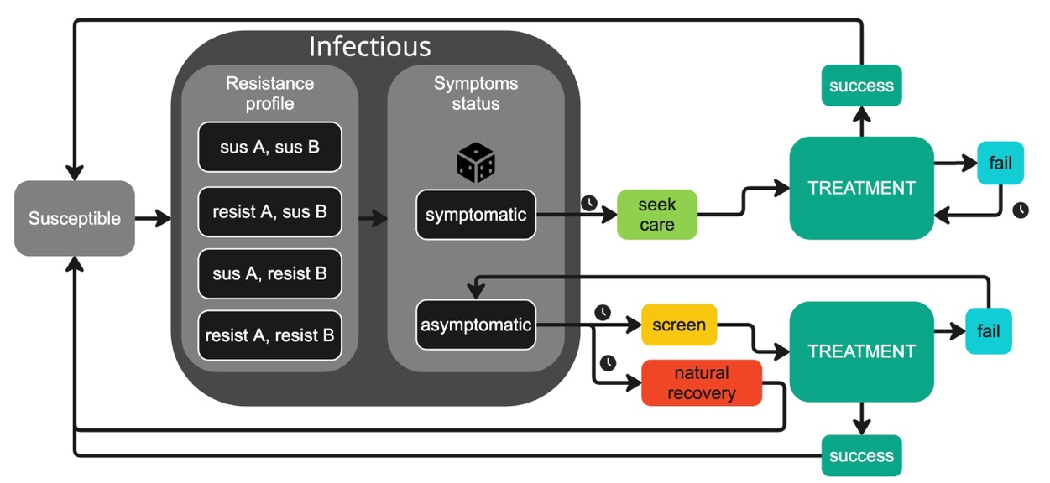
Figure 1. Diagram of the major processes of the model, showing the generic treatment pathway. “sus A” and “sus B” represent susceptibility to drug A and drug B, respectively, and “resist A” and “resist B” represent resistance to drug A and drug B, respectively. Dice icon indicates a pseudo-random event, whose probability is controlled by a parameter. The clock icon indicates that time elapses before the next event occurs; arrows without clock icons indicate that the next event takes place immediately.

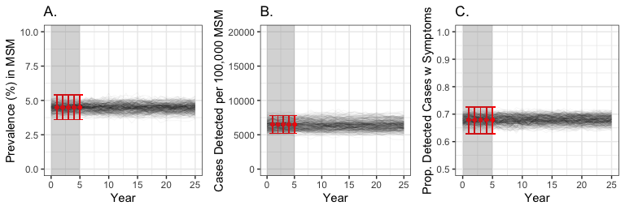
Figure 2. Comparing calibration targets (shown in red) with simulated trajectories without AMR for 25 years. A) prevalence of infection. B) gonorrhea cases detected per 100,000. C) proportion of detected cases that present with symptoms. Darkness of the black lines relates to how frequently that trajectory was resampled, according to its likelihood when compared to the calibration target. Red dots indicate the observed value, and the red error bars indicate the confidence interval (see text for data sources). The grey region represents the calibration period.

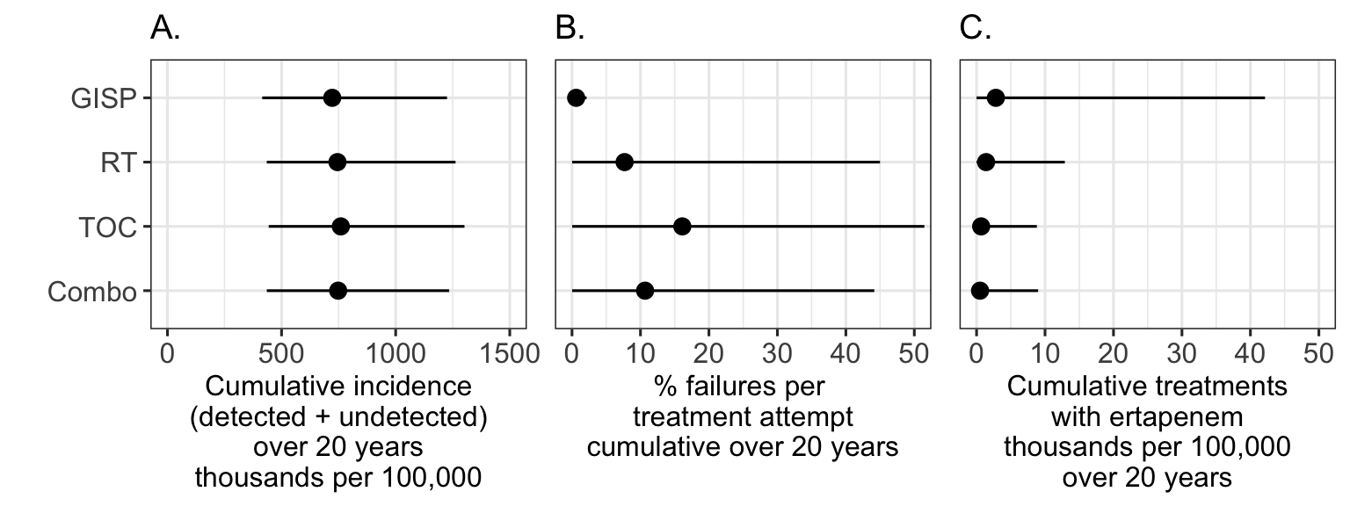
Figure 3. Cumulative outcomes for the four mitigation strategies, beginning at the end of the calibration period and continuing to the end of each simulation. Dot indicates the mean model prediction; line corresponds to the 95% uncertainty interval (i.e., extending from the 2.5% quantile to the 97.5% quantile). A) total infection incidence, including both detected and undetected infections. B) percentage of treatment attempts that resulted in treatment failure for drugs A, B, and X. C) count of treatments with ertapenem.
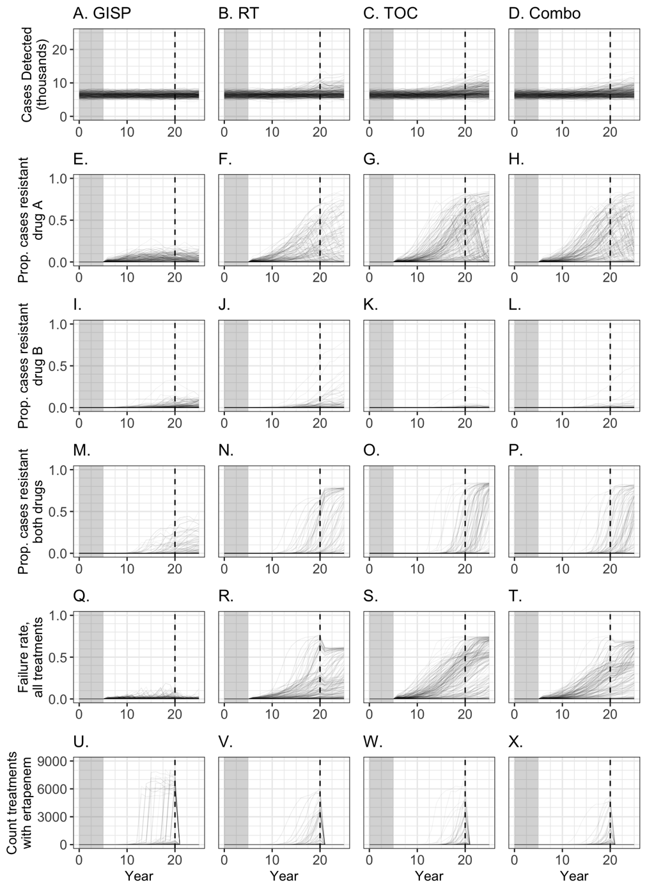
Figure 4. Trends over time in cases detected (first row), prevalence of AMR strains (rows 2-4), treatment failure rate (row 5), and usage of ertapenem, the last-line treatment (row 6) across four strategies. GISP: the surveillance strategy; RT: randomized treatment strategy; TOC: test-of-cure strategy; Combo: combination of RT and TOC. The gray box indicates the calibration period, during which all strategies performed identically. The dashed vertical line indicates when drug X became available in the simulation. Darkness of trajectory lines relates to their likelihood weights (see S1.3).

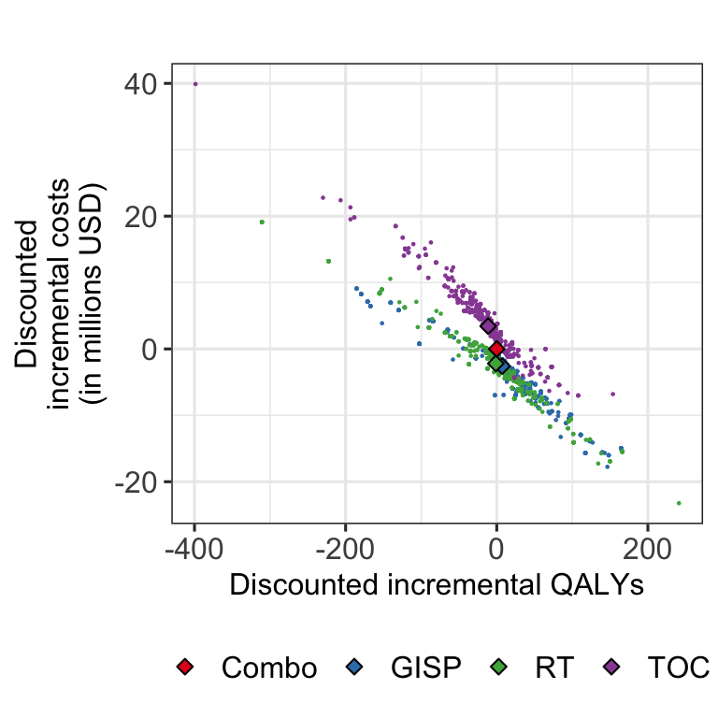
Figure 5. Cost-effectiveness analysis of GISP and three counterfactual strategies. Combination of TOC and RT (Combo) is used as the reference strategy, located at (0,0). Small dots are values from individual trajectories, diamonds are means of each counterfactual (mean was weighted by how frequently that trajectory had been resampled during calibration.)

Tables
Table 1. Mean cumulative results (uncertainty intervals) of four measures of gonorrhea burden: gonorrhea incidence, antimicrobial-resistant (AMR) gonorrhea incidence, treatment failure rate, and total count of treatments with ertapenem
 | GISP* | Randomized  Treatment (RT)† | Test of Cure  (TOC)‡ | Combo§
Cumulative incidence of gonorrhea over 20 years | 722,096  (415,122, 1,225,184) | 744,987  (435,196, 1,262,317) | 759,672  (443,702, 1,301,533) | 748,082  (435,395, 1,234,573)
Cumulative incidence of AMR gonorrhea over 20 years | 28,756  (151, 143,318) | 99,273  (112, 592,069) | 155,983  (157, 745,978) | 120,252  (98, 584,297)
Treatment failure rate | 0.60%  (0.02, 2.13) | 7.68%  (0.01, 44.99) | 16.11%  (0.03, 51.47) | 10.68%  (0.02, 44.15)
Total count treatments with ertapenem | 2,818  (0, 42,129) | 1,390  (0, 12,890) | 668  (0, 8,805) | 508  (0, 8,991)
Cumulative results of gonorrhea burden under GISP and three counterfactual strategies, beginning at the end of the calibration period (year 5). Presented are the means of 380 unique trajectories; in parentheses are the 95% uncertainty intervals, derived from the 2.5% and 97.5% quantiles of the simulated data. Cumulative incidence of gonorrhea includes both detected and undetected infections. Cumulative incidence of antimicrobial-resistant (AMR) gonorrhea includes both detected and undetected infections of all resistant strains, combined. Treatment failure rate is calculated as the number of treatment failures divided by the number of all treatment attempts.
*GISP: Gonococcal Isolate Surveillance Project, where treatments were removed from use when GISP surveillance data indicated AMR resistance of 5% or greater.
†RT: Randomized Treatment, where treatment was selected randomly from available drugs.
‡TOC: Test-of-Cure, where some cases received confirmatory diagnostic testing after treatment attempts.
§Combo: Combination, where cases were randomly assigned to RT or TOC
Table 2. Cost-effectiveness results: Cost, number of quality-adjusted life years (QALYs), and incremental cost-effectiveness ratios for four strategies.
Alternative | Cost (millions USD) | QALYs¶ lost | ICER#
GISP* | 18.28  (14.25, 28.46) | 222.3  (147.9, 389.3) | Cost-saving
RT† | 18.68  (14.07, 29.36) | 230.7  (147.2, 400.8) | Dominated
Combo‡ (Reference) | 20.87  (15.56, 33.83) | 229.4  (145.0, 367.8) | Dominated
TOC§ | 24.30  (17.29, 40.14) | 240.8  (148.7, 385.6) | Dominated
The strategies are listed in increasing order of cost. Costs and QALYs were cumulative from year 5 to year 25 in the model, with 3% discounting year-over-year. Presented are the means of 380 unique trajectories; in parentheses are the 95% uncertainty intervals, derived from the 2.5% and 97.5% quantiles of the simulated data. Costs are in 2022 United States dollars (USD).
*GISP: Gonococcal Isolate Surveillance Project, where treatments were removed from use based on surveillance
†RT: Randomized Treatment, where treatment was selected randomly from available drugs
‡Combo: Combination, where cases were randomly assigned to RT or TOC
§TOC: Test-of-Cure, where some cases received confirmatory diagnostic testing after treatment attempts
¶QALYs: Quality-Adjusted Life-Years. These values represent decrements in QALYs that resulted from gonorrhea.
#ICER: incremental cost-effectiveness ratio

- Model description, calibration, and validation
  - Additional model details
    - Infection Transmission & Activity Groups
The population is divided into two sexual activity groups: high-activity and low-activity. These activity groups are meant to represent heterogeneity in frequency of casual sexual behavior. The relative size of the activity groups is determined by the parameter propHighActivity (prior range, 0.05 to 0.35). For each trajectory, the number of individuals in the high-activity group remains constant at 100,000 * propHighActivity. At the beginning of each simulation year, all individuals have a chance of switching activity groups, as controlled by the parameter activityGroupTransferProp. From the population of 100,000, a randomly selected subset of (100,000 * activityGroupTransferProp) have their activity group changed to the opposite of what it previously was. In this way, the total size of the high-activity and low-activity groups is maintained throughout each trajectory.
Infectious individuals infect other individuals at a rate controlled by the TransmissionMSM ($λ$) parameter. Each timestep during which an individual is infectious, a pseudo-random number is compared to a weekly transmission probability. This transmission probability is affected by the activity group that the individual is currently in. The high-activity group is meant to represent those who are at a higher risk of gonorrhea exposure due to a higher rate of casual sexual contact. Therefore, individuals in the high-activity group have a higher probability of transmission during each week of infection, calculated as $1-e^{-λ /52}$, where $λ$ is the parameter TransmissionMSM. For the low-activity group, the weekly transmission probability is decreased by factor ActivityGroupTransmissionRatio (ρ); the weekly transmission probability for a low-activity individual is $ρ(1-e^{-λ /52}$), with $ρ$ being a value between 0.05 and 0.5. Therefore, the probability of an individual from the low-activity group transmitting their infection is, at most, half as likely as that of an individual from the high-activity group transmitting their infection. If it is determined that an infectious individual should transmit during this timestep, a sexual partner is selected. The Assortativity parameter is used to determine whether the sexual partner will be of the same activity group as the perspective agent, or of the other activity group. Then, the partner is randomly selected from among the current members of the selected activity group. All infection transmission parameters are also described in Table S1.
    - Care-seeking and screening
Upon the individual being infected, the infection is determined to either be symptomatic or asymptomatic, using the ProbSymptomaticMSM parameter as the probability. Then, the pathways for symptomatic and asymptomatic infections diverge (Figure 1).
Symptomatic infections result in the individual seeking care, with a delay drawn from an exponential distribution with mean DelayToSeekCareMSM. Once this delay has elapsed, the individual receives some treatment, depending on the counterfactual currently implemented and what events have already elapsed in that simulation run (e.g., a change in empiric treatment recommendations). If the attempted treatment fails, then the symptomatic individual will receive retreatment after a delay drawn from an exponential distribution with mean DelayToRetreatmentMSM. This will repeat until the infection has been treated successfully.
For asymptomatic infections, these may clear naturally after a time interval drawn from an exponential distribution with the expected value NaturalRecoveryTime has elapsed. This parameter describes a distribution from which each infection has its natural recovery time drawn at the moment of infection. Asymptomatic infections can also be detected through screening. The time between screenings is drawn from a Gamma distribution with mean ScreenIntervalMeanMSM and variance ScreenIntervalVarMSM. More detail on how screening times were generated is available in the ODD (S2.7 Submodels). If first treatment fails for an asymptomatic infection, the individual could continue to infect others until either another screening or natural recovery took place. Under the test-of-cure strategy, asymptomatic treatment failures could be caught by re-testing (Figure S2).
    - Resistance
After year 5 of the simulation, we allowed resistance to be developed in response to antibiotic treatment or be imported:
- Response to treatment. During each treatment, the infection had a very low (ranging from 0.000001 to 0.001) probability of developing resistance to the current treatment. This probability was controlled by two different parameters for drugs A and B. Parameter values were drawn from a uniform distribution with a range of -3 to -6, and then 10 was raised to the power of that value to compute the probability of developing resistance. When an infection became resistant to the current treatment, it had a new chance of being symptomatic or asymptomatic (i.e., a new pseudo-random number was drawn and compared to ProbSymptomaticMSM to determine the presence of symptoms for the “new” resistant infection).

- Importation. To import resistance to drug A after the calibration period, we converted a proportion of current infections (controlled by the parameter percentResistantA) from non-resistant to resistant to A. To import resistance to drug B, we more gradually added individual infections with resistance to B. The beginImportingB parameter controlled when infections resistant to drug B began to be imported into the model. The parameter value was the timestep at which the first infection with resistance to B was added to the population. The importingBInterval parameter controlled the length of time between importations of single infections resistant to drug B. The process for generating the intervals using this parameter was similar to that used for screening intervals (see below).
  - Cost parameters
Since there is uncertainty around the exact cost of different treatment events, these costs were implemented as parameters and allowed to vary between simulations. For each simulation, each cost parameter value was drawn from a gamma distribution, as defined by mean and variance values taken from Yin et al.¹ and detailed in Table S2.
  - Calibration
A parameter sweep was conducted, where 300,000 combinations of unknown parameter values were randomly drawn, and the model was run for ten years (5-year burn-in period + 5-year calibration period). For the parameter sweep, new values for each of the parameters and for the random seed were selected. Main model parameter values were drawn from uniform distributions (with prior ranges listed in Table S1). During the calibration period, we assumed that resistance to current and future antibiotics (drugs A, B, and X) are negligible. To calibrate our activity groups, we imposed constraints so that the trajectory was terminated if the high-activity group had gonorrhea prevalence above 25% or below 5%, or if the low-activity group had gonorrhea prevalence greater than 4%. To make the calibration procedure more efficient, we also terminated trajectories before the end of the calibration period if whole-population gonorrhea prevalence exceeded 10% or went below 0.05%. Parameter combinations generating these terminated trajectories were not considered in further analysis.
For each trajectory under consideration, we calculated the likelihood of producing observed values of prevalence, annual incidence of reported cases, and the proportion of detected cases which were symptomatic.
- For prevalence, the model’s prevalence output was used to generate a Binomial distribution, where model prevalence was the probability of success. The likelihood of that trajectory’s prevalence was the density of the distribution for 93 successes out of 2,075 trials ².
- For detected incidence, the model’s detected incidence output was used to generate a Normal distribution, where model detected incidence was the mean and detected incidence divided by five was the standard deviation. The likelihood of that trajectory’s detected incidence was the density of the distribution for x = 6,508 ³.
- For the proportion of detected cases with symptoms, the model’s rate of cases with symptoms was used as the probability parameter of a Binomial distribution. The likelihood of that trajectory’s rate of cases with symptoms was the density of the distribution for 233 successes out of 343 trials ⁴.
The likelihoods of all trajectories ($l_{1}, l_{2}, …,l_{N}$) were scaled to the maximum calculated likelihood ($L_{max}$) to obtain the probability weights ($w_{i}$s) according to the following formula:
$$w_{i} = {e^{(l_{i}-L_{max})}/W}_{, }$$
where $W=\sum_{i}{e^{(l_{i}-L_{max})}}.$
These probability weights were then used to resample 1000 trajectories, with replacement, to project the impact of different strategies. This resampling step resulted in 337 unique trajectories. These exact parameter values (including the random seed) were saved to be re-imported into the model. The frequency with which certain trajectories were repeatedly resampled was later used to weight the results of the counterfactual simulations.
Parameter estimates (including repeated resampling of the same trajectory) are shown in Figure S3. Running these 380 trajectories without the addition of AMR resulted in stable outcomes over time, remaining within the range of the calibration targets (Figure 2).
We assessed goodness-of-fit of our posterior trajectories to the calibration targets using a few metrics. These results are available in Table S5.

  - Model Validation
To ensure that parameters were having the expected effects on outcomes, we calculated partial rank correlation coefficients for a variety of parameters on several outcomes, either at the conclusion of the simulation (prevalence, proportion of cases presenting with symptoms) or cumulative (incidence, monetary costs, QALYs). Partial-rank correlation coefficients (PRCC) were calculated for a run on the base model settings (i.e., drug X available in year 20, 80% TOC adherence, 80% DST coverage) with the same calibrated trajectories as presented in the main text. Infection parameters (i.e., transmission, screenInterval, probSymptomatic, delayToSeekCare) tended to have strong influence on outcomes. Occasionally the parameters controlling resistant strain importation (percentResistantA, importingBInterval) also had a strong influence. The cost parameters had some impact on cumulative monetary costs, especially CareCost and TestCost (diagnostic test cost). PRCC results are available as an online supplement (zip folder of CSV files).
We also informally compared certain model outcomes/behaviors to real-world data. This included the rate of developing sequelae (specifically, disseminated gonococcal infection, DGI) and the number of male sexual partners an individual reported in the past 12 months.
- From the model, we took the incident cases of DGI and divided this by the detected cases of gonorrhea. The result was a DGI rate of 1.858% (95% UI, 0.92-3.443%). Data on gonococcal sequelae in men is scarce,⁵⁻⁷ but suggests a similar range of 0.5% to 3% detected cases developing DGI.
- Because the model only represents sexual contact which leads to gonorrhea transmission, model data is not directly comparable to any real-world data on sexual contact rates. However, because the transmission rate would have to be lower than the contact rate, we decided to compare these values to ensure the model was within the realm of reality. We calculated a transmission-per-infection-year rate by dividing the number of transmissions each infection resulted in, divided by the infection’s duration in years. For each simulation trajectory, we recorded the 25%, 50% (median), and 75% quantiles, and examined the distributions of these summary statistics (see Figure S4). The National HIV Behavioral Surveillance special reports from 2008,⁸ 2014,⁹ and 2017¹⁰ provide the 25%, 50% (median), and 75% quantiles for the self-reported number of male sex partners in the previous 12 months. Since the vast majority of infections led to no onward transmissions, both the 25% and median transmissions-per-infection-year were universally 0; this is lower than the NHBS data, but in the expected direction. However, the 75% quantile values ranged from around 5-25, indicating that the distributions of transmissions-per-infection-year had a long and variable tail. Moreover, this range and distribution of the 75% quantile transmissions-per-infection-year appears similar to the NHBS 75% quantile of male sex partners per year. This indicates that the sexual interaction rate within the model falls within the range of what has been reported previously. From this analysis, we also determined that there was no meaningful difference in interaction rate among the counterfactual scenarios.

  - Supplement Figures
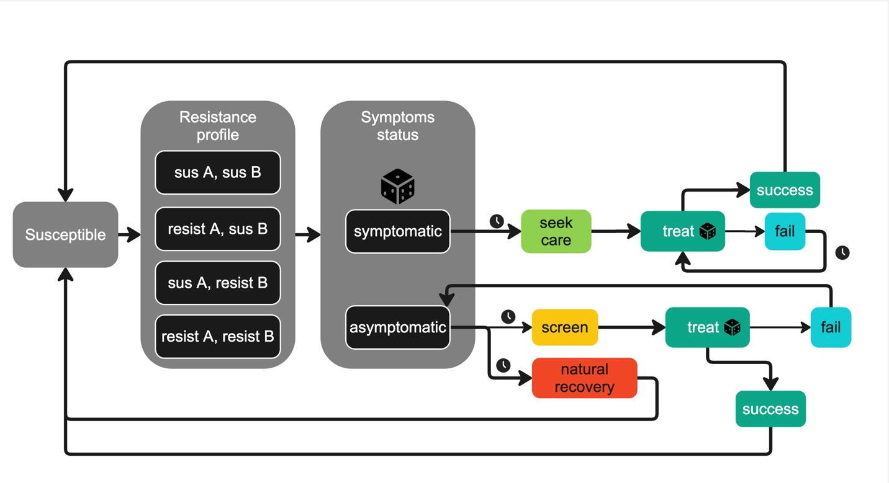
Figure S1. Model diagram for GISP and randomized treatment (RT) counterfactuals. “sus A” and “sus B” represent susceptibility to drug A and drug B, respectively, and “resist A” and “resist B” represent resistance to drug A and drug B, respectively. Dice icon indicates a pseudo-random event, whose probability is controlled by a parameter. The clock icon indicates that time elapses before the next event occurs.

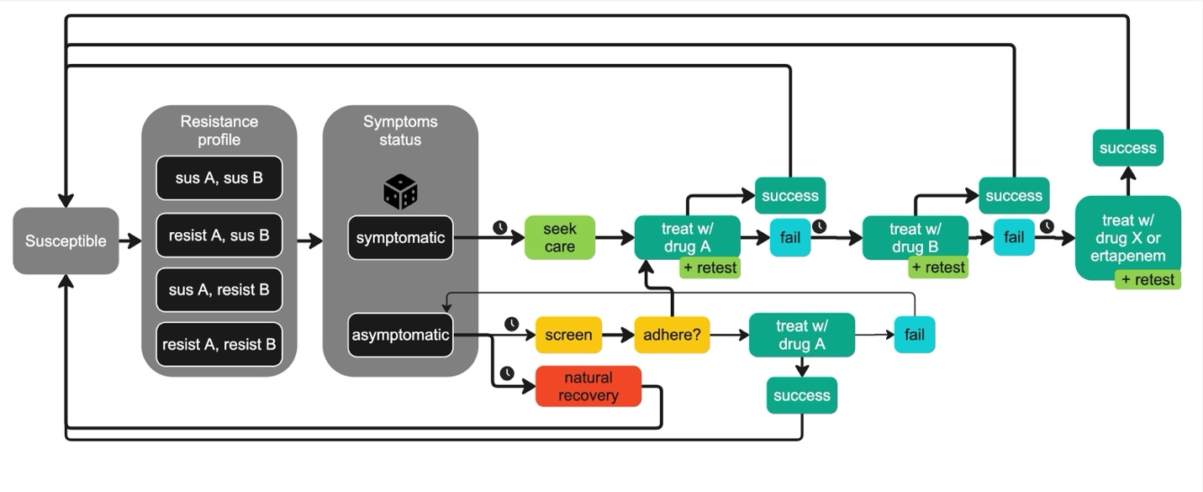
Figure S2. Model diagram for test-of-cure (TOC) counterfactual. See Figure S1 caption for symbol explanations.

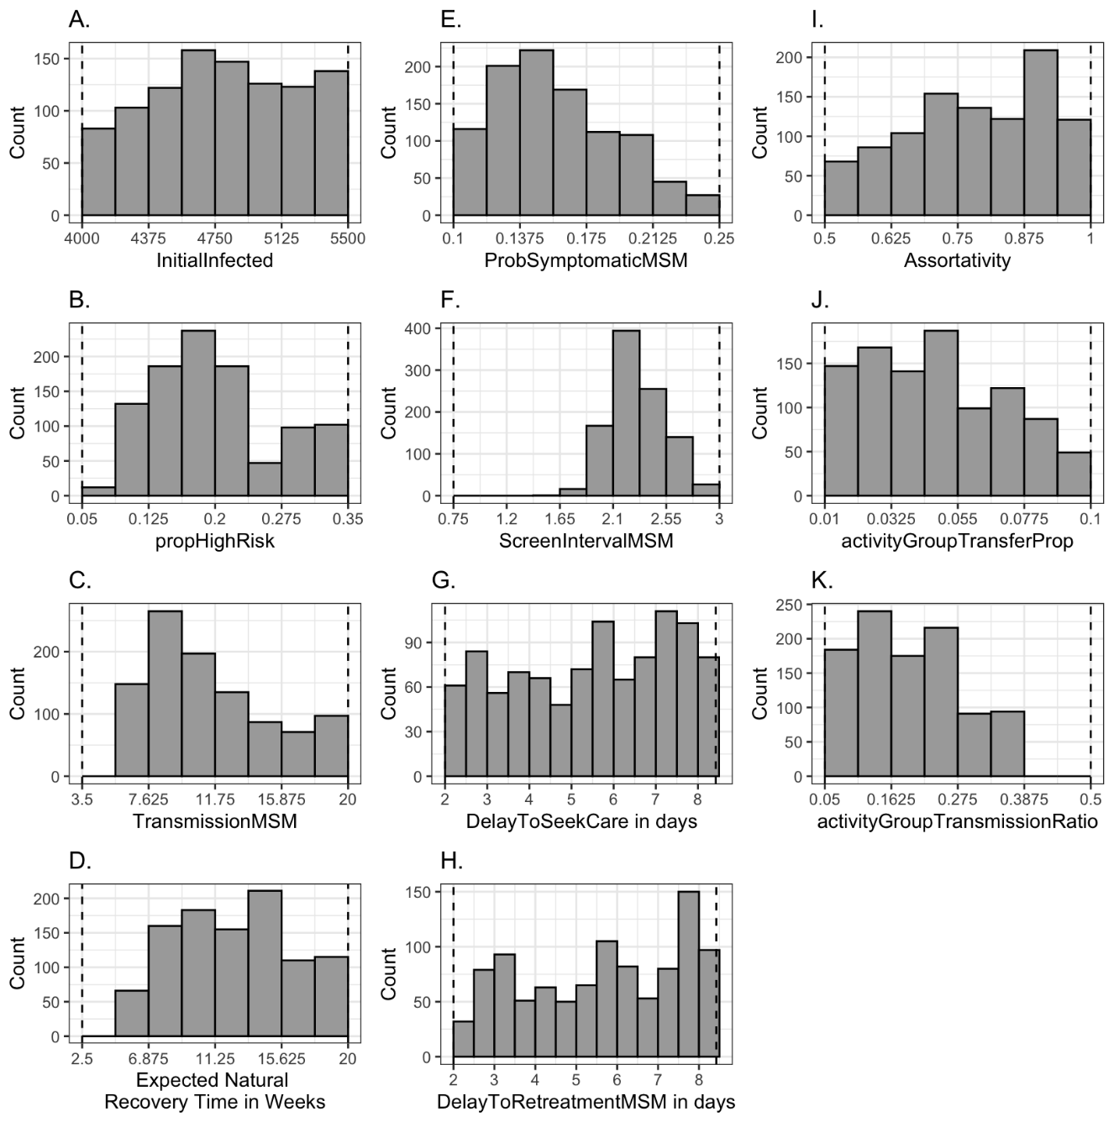
Figure S3. Parameter estimates, based on resampling with replacement based on trajectory probability weights (see §S1.3). Dashed vertical lines in all panels indicate the ranges of the prior distributions (Table S1).

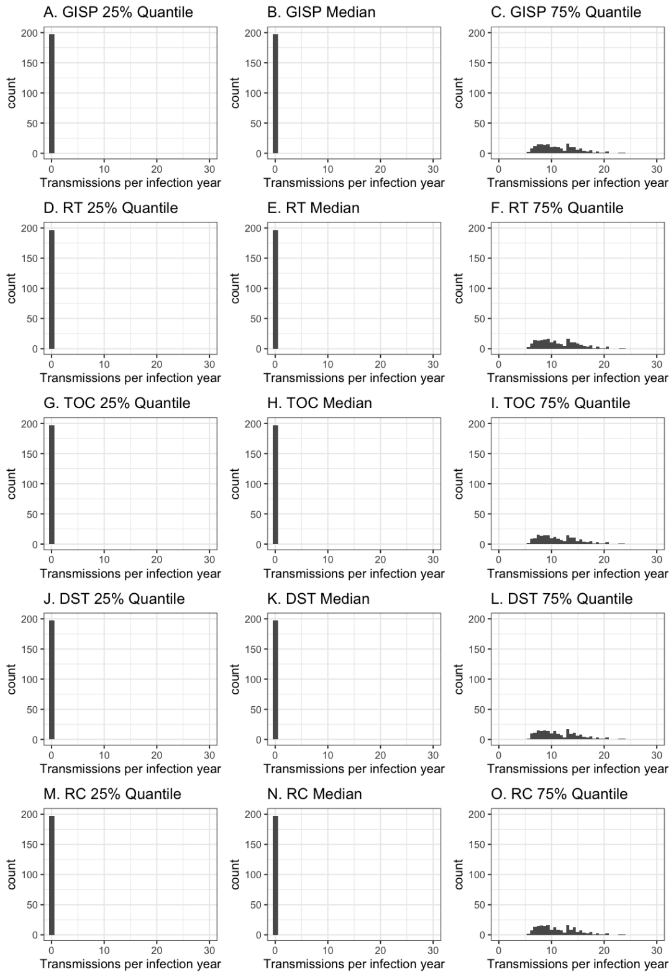
Figure S4. Transmissions per infection per year under select counterfactual scenarios. From all of the infections which occurred in each trajectory, the rate of transmissions per infection per year was calculated by dividing the number of transmissions of that infection by its duration in years. Then, the distribution of rates was used to calculate the 25%, 50%, and 75% quantiles. These values were tallied across trajectories and are presented in this figure.

  - Supplement Tables
Table S1: Model parameters. Reference refers to the range of the prior distribution. For those where the only reference is “assumption” (except beginImportingB and ImportingBInterval), we started with much wider prior distributions. Over time with repeated parameter sweeps and calibration attempts, we narrowed down the prior distributions, so that calibration would select more unique trajectories (goal of >200 unique trajectories in our resampling with replacement).
Parameter name and Description | Implementation in model | Prior distribution (all Uniform) | Reference
TransmissionMSM: annual rate of infection transmission | Parameter is converted into a weekly likelihood (see §S1.1.1). | 3.5 – 20 | Assumption
NaturalRecoveryTime: Duration of infectiousness in absence of treatment in years | Each new infection has recovery time drawn from an exponential distribution with mean equal to this parameter value. | 0.0577 – 0.385 years  (3-20 weeks) | ^{11,12}
ProbSymptomaticMSM: Probability infection is symptomatic | Each new infection compares a new random number to the parameter value to determine symptom status | 0.10 – 0.25 | ⁴
ScreenIntervalMeanMSM: Controls mean of how frequently agents get tested via screening, in years | The time between screening events is drawn from a Gamma distribution with this mean; see S2.7 for more detail | 1.75 – 3.0 years | ¹³
ScreenIntervalVarMSM:  Controls variance of how frequently agents get tested via screening, in years | The time between screening events is drawn from a Gamma distribution with this variance; see S2.7 for more detail | 1.75 – 3.0 years | ¹³
Assortativity: degree of preference for partnering with members of own activity group | Each time indiv selects a partner, if random value [0-1] compared to assortativity (see S1.1) | 0.5 – 1.0 | Assumption of positive assortativity
propHighActivity: the proportion of the population assigned to the high activity group | See S1.1 and S2.5 | 0.05 – 0.35 | Assumption
activityGroupTransferProp: proportion of population that switches activity groups every year | At the end of each year, (population size * activityGroupTransferProp) individuals are instructed to change their activity group | 0.01 – 0.3 | Assumption
ActivityGroupTransmissionRatio: modifies transmission likelihood for low-activity group | For low-activity infectious individuals, their chance of transmitting each week is multiplied by parameter value | 0.05 – 0.5 | Assumption low-activity << high activity
InitialInfected: amount of indivs infectious at t=0 | See S2.5 | 4000 – 5500 indivs | ²
DelayToSeekCare: time between infection and seeking care for symptomatic case, in years | For each symptomatic case, time to enter care is drawn from Exp distribution with mean equal to this parameter value | 0.0055 – 0.023 years  (2-8 days) | ¹⁴
DelayToRetreatment: time between failed treatment and next treatment, in years | For each failed treatment, time until receiving next treatment is drawn from an exponential distribution with mean equal to this parameter value | 0.0055– 0.023 years  (2-8 days) | ¹⁵
percentResistantA: number of infections which are converted to resistant to A at year 11 | After the calibration period, a proportion of current infections are replaced with infections resistant to drug A. | 0.001 – 0.05 | ¹⁶
beginImportingB: the model year during which resistance to B started being imported | The first infection resistant to drug B will be added to model at the time determined by this parameter. | Year 15 – 20 | Assumption
ImportingBInterval: the expected time interval between importation of individual cases resistant to B, in years | The parameter value is expected value of Exp distribution from which time to next importation of case resistant to B is drawn | 0.0769 – 2 years | Assumption
ProbDevelopResistanceAExponent
ProbDevelopResistanceBExponent

Table S2: Cost parameters in 2022 USD (all assumed to follow Gamma distributions with mean and standard deviations provided below).
Parameter name and Description | Mean | Standard Deviations | Ref
CareCost: Cost of short clinic + treatment of urethritis | 133 | 32 | ¹
TestCost: Cost of diagnosis | 68 | 16.25 | ¹
StrainTestCost: Cost of drug susceptibility test (both rapid for rDST scenario and culture-based used for GISP scenario) | 150 | 25 | ¹
DrugATreatmentCost: Cost of treatment with ceftriaxone | 24 | 3 | ¹
DrugBTreatmentCost: Cost of treatment with new first-line drug | 24 | 3 | ¹
DrugXTreatmentCost: Cost of treatment with hypothetical first-line drug developed in the next 10-30 years | 24 | 3 | ¹
ErtapenemTreatmentCost: Cost of treatment with ertapenem (in-patient, intravenous or intramuscular administration of broad-spectrum antibiotic) | 537 | 122.75 | ¹

Table S3. Sequelae-associated constants. Probabilities of, costs of, and QALYs lost from sequelae did not vary during the parameter sweeps. There was the below chance of an infection developing sequelae each time a treatment attempt failed, each time an asymptomatic infection became “undetected” due to treatment failure, and each time an infection was about to clear naturally. Initial probabilities were taken from Yin et al. 2024,¹ and then adjusted (reduced by half) based on available data on the incidence of disseminated gonococcal infection. Developing epididymitis and developing DGI were treated as separate events, so the probability of developing both during the same sequelae check was p(epididymitis) * p(dgi).
Sequela | Prob. | Cost in 2022 USD | QALY reduction | Duration in days (for QALYs)
Epididymitis | 0.021¹ | $522¹ | 0.128¹⁷ | 6.9¹
Disseminated gonococcal infection (DGI) | 0.005¹ | $2,916¹ | 0.37¹ | 8.8¹
Epididymitis + disseminated gonococcal infection | 0.000105 | $3,438¹ | 0.7102¹ | 15.7 (Duration of epididymitis + duration of disseminated gonococcal infection) ¹

Table S4. Other QALY loss constants.
Constant and description | QALY reduction | Duration in days | Ref
Symptomatic infection | 0.114 | Dependent on delay to seek care and delay to retreatment | ^{1,17}
Side effects of ertapenem | 0.3 | 10.5 | ¹

Table S5. Goodness-of-fit metrics for the comparison between the calibration targets and the calibration posterior distributions of model outcomes.
 | Calibration Target | Posterior estimate (mean) | Posterior 95% CI | Posterior 50% CI | Target Within 95% CI? | Target Within 50% CI? | Absolute Error | Relative Error (%) | Z-score | Posterior Predictive P-value | 95% CI Overlap
Prevalence | 4.50 | 4.48 | (3.94, 5.02) | (4.28, 4.67) | TRUE | TRUE | 0.02 | 0.50 | 0.08 | 0.47 | 0.75
Detected cases | 6508.00 | 6440.42 | (5251.75, 7878.00) | (5883.75, 6936.75) | TRUE | TRUE | 67.58 | 1.04 | 0.10 | 0.44 | 0.98
Proportion detected cases symptomatic | 0.68 | 0.68 | (0.65, 0.71) | (0.67, 0.69) | TRUE | TRUE | 0.00 | 0.18 | -0.08 | 0.54 | 0.62

Add PRCC tables here?
  - S1.7. References
1. Yin X, Li Y, Rönn MM, et al. Assessing thresholds of resistance prevalence at which empiric treatment of gonorrhea should change among men who have sex with men in the US: A cost-effectiveness analysis. PLOS Medicine 2024; 21(7).
2. Johnson Jones ML, Chapin-Bardales J, Bizune D, et al. Extragenital Chlamydia and Gonorrhea Among Community Venue–Attending Men Who Have Sex with Men — Five Cities, United States, 2017. MMWR Morbidity and Mortality Weekly Report 2019; 68(14): 321-5.
3. Centers for Disease Control and Prevention. Sexually Transmitted Disease Surveillance 2018, 2019.
4. Newman LM, Dowell D, Bernstein K, et al. A Tale of Two Gonorrhea Epidemics: Results from the STD Surveillance Network. Public Health Reports 2012; 127(3): 282-92.
5. Hook EI, Handsfield H. Gonococcal infections in the adult [Chapter 35]. In: Holmes K, Sparling P, Stamm W, eds. Sexually Transmitted Diseases. 4 ed. New York, NY: McGraw-Hill Medical; 2008: 627-45.
6. Tang EC, Johnson KA, Alvarado L, et al. Characterizing the Rise of Disseminated Gonococcal Infections in California, July 2020–July 2021. Clinical Infectious Diseases 2023; 76(2): 194-200.
7. Weston EJ, Heidenga BL, Farley MM, et al. Surveillance for Disseminated Gonococcal Infections, Active Bacterial Core Surveillance (ABCs)—United States, 2015–2019. Clinical Infectious Diseases 2022.
8. Bowles KE, Cribbin M, DiNenno E, et al. HIV risk, prevention, and testing behaviors among men who have sex with men; National HIV Behavioral Surveillance System, 21 U.S. cities, United States, 2008. 2011.
9. HIV Surveillance Special Report: 2014; no.15.
10. Centers for Disease Control and Prevention. HIV Infection risk, prevention, and testing behaviors among men who have sex with men National HIV behavioral surveillance 23 U.S. cities, 2017. Atlanta, GA, 2019.
11. Barbee LA, Soge OO, Khosropour CM, et al. The Duration of Pharyngeal Gonorrhea: A Natural History Study. Clinical Infectious Diseases 2021; 73(4).
12. Barbee LA, Khosropour CM, Soge OO, et al. The Natural History of Rectal Gonococcal and Chlamydial Infections: The ExGen Study. Clinical Infectious Diseases 2022; 74(9).
13. Hoover KW, Butler M, Workowski K, et al. STD Screening of HIV-Infected MSM in HIV Clinics. Sexually Transmitted Diseases 2010; 37(12).
14. Aaron KJ, Van Der Pol B, Jordan SJ, Schwebke JR, Hook EWI. Delay in Seeking Health Care Services After Onset of Urethritis Symptoms in Men. Sexually Transmitted Diseases 2019; 46(5).
15. Schlanger K, Mauk K, Learner ER, et al. Test of Cure Return Rate and Test Positivity, Strengthening the US Response to Resistant Gonorrhea, United States, 2018–2019. Sexually Transmitted Diseases 2021; 48(12S).
16. Centers for Disease Control and Prevention. Sexually Transmitted Infection Surveillance 2021: Gonococcal Isolate Surveillance Project Profile. Atlanta, GA: US Department of Health and Human Services, 2023.
17. Global Burden of Disease Collaborative Network. Global Burden of Disease Study 2019 (GBD 2019) Disability Weights. In: (IHME) IfHMaE, editor. Seattle, United States of America; 2020.

- ODD Protocol Model Description
The model description below follows the ODD Protocol put forward by Grimm et al. (2006, 2010, 2020).

  - Purpose and Patterns
This model’s purpose was to assess the cost-effectiveness of surveillance methods for antimicrobial resistance in gonorrhea in the US. It was also developed with the goal of being flexible enough to incorporate multisite infection and different kinds of sexual behavior for future investigations.
The patterns to which the model was matched were infection,¹ detected disease cases per 100,000,² and the proportion of detected cases which present as symptomatic.³

  - Entities, state variables, and scales
Main entities were individuals (Class Indiv) and infections (Class Infection). Other aspects of the program were also implemented as objects, including the Observer (Class Observer), population (Class Population), screener (Class Screener), care-seeking (Class CareSeeking), tests (Class Testing), treatments (Class Treatment), cost calculator (Class CostCalc), and the surveillance program (Class SurveillanceProgram).

Individuals (Class Indiv) were the principle agents, and represented humans in the population. Individuals had a “state” attribute that indicated whether they were susceptible (0) or infectious (1), and an attribute that references the infection they had (null, if currently susceptible). Individuals had an attribute “riskGroup”, which indicated whether they were currently in the high-risk or low-risk sexual activity group. Individuals also had a list of all the timesteps on which a screening should take place, as taken from the normal distribution controlled by the screenInterval parameter. Individuals had a Boolean attribute indicating whether they were currently abstaining from sexual activity. Individuals had a Boolean attribute indicating whether their current infection had had a care-seeking event schedule already, so that this was not redundantly scheduled for the same Indiv and infection. Individuals also contained reference to the parameters, the population, the observer, the schedule, and the random helper.

Infections (Class Infection) represent the population of bacteria Neisseria gonorrhoeae within the host individual. Infections had a string attribute, strain, which could be assigned values of “none” (susceptible to all drugs), “A” (for resistant to drug A but susceptible to B), “B” (for resistant to drug B but susceptible to A), or “Both” (for resistant to both drugs A and B, but susceptible to drug X). For ease of access, drug resistance information was also stored as two Boolean attributes: resistanceToA and resistanceToB. Infections also had three other Boolean attributes: current, symptoms, and starting. “Current” served as a redundancy, so that recovered infections could not continue to infect others. “Symptoms” indicated whether the infection was producing symptoms that would lead to care-seeking behavior. “Starting” indicated whether this as an infection present at initialization, because the proportion symptomatic was different in the starting set of infections. Infections could only be accessed through reference to the host Indiv.

The Observer (Class Observer) is an object instance which exists only to collect data on the Indiv population. In order to collect and output these data, it contains reference to the schedule, the population, and the cost calculator.

The Population (Class Population) is an object instance containing reference to all Indivs within a single simulation run. The class also contains methods for subsetting the Indiv population by infection status, risk group, or other attribute.

Treatments (Class Treatment) are objects that are created after a case is detected through either seeking care or screening. The treatment object saves information on the individual and the infection, as well as references to the observer, cost calculator, and certain global states. For each infection case detected, the treatment class handles treatment attempts, treatment failures, and retreatment attempts according to the counterfactual being implemented.

The cost calculator (Class CostCalc) is a single object per simulation which tallies the monetary costs and quality adjusted life years (QALYs) lost for all individuals in the population. This information is then passed to the Observer for output.

The surveillance program (Class SurveillanceProgram) is a single object per simulation which implements a sampling program based off GISP. The first 25 detected cases during each four-week period undergo drug susceptibility testing, the results of which are pooled for each year. Then, if the annual level of resistance in the sample is greater than 5%, first-line treatment recommendation is adjusted. SurveillanceProgram is only active with the GISP scenario.

Each timestep represents one week of real-world time. Simulations typically run for up to 1560 timesteps, i.e., representing 30 years of gonorrhea transmission, of which the first 10 years are made up of a burn-in period and a calibration period.

  - Process Overview and Scheduling
For each simulation run, a unique ThreadSafeSchedule instance is created. Events are added to the schedule for future execution.
For the sake of efficiency, only infectious individuals are processed. For each timestep during which an individual is infected, the following procedure (“infectiousActions()”) is attempted:
- It is checked if the individual is still infectious, and had not recovered in the previous timestep. If the individual is not infectious, no further actions occur, and the individual goes dormant.
- It is checked if the infection is currently detected. If not, it is checked if the infection should be detected:
  - It is checked if the infectious individual is symptomatic (i.e., would exhibit care-seeking behavior) and does not already have seeking care scheduled. If both are true, the individual has care-seeking scheduled for a future timestep as controlled by the parameter DelayToSeekCareMSM, and the individual’s attribute seekCareScheduled is set to true (so that this step is not repeated unnecessarily). If the individual is not symptomatic or already has seeking care scheduled, they continue with the rest of the infectious actions below.
  - If the infection is not symptomatic, it is checked if this is a timestep during which a screening is scheduled for this individual. If the individual is scheduled for a screening, the individual is screened (class Screener).
    - When an individual is screened, it is confirmed that their current state is infectious. (Otherwise, nothing further will happen, and the individual will ultimately go dormant.) If they are infectious, the case is recorded as detected, and the individual immediately receives treatment (class Treatment).
    - Upon receiving treatment, screened individuals without resistance immediately recover. Individuals who are asymptomatic AND resistant to the treatment received have their treatment fail. This means that their state remains infectious, and they are still able to attempt to infect other indivs.
- If the Indiv is still infectious after the previous steps (i.e., asymptomatic and not screened, or, symptomatic but still waiting to seek care, or, having recently failed treatment), then the Indiv has a chance of transmitting their infection to another Indiv (method attemptContact()).
  - In the attemptContact() method, the weekly transmission probability is calculated by the parameter TransmissionMSM, and, for low-risk group individuals, RiskGroupTransmissionRatio. A randomly-generated value between 0 and 1.0 has to be less than this weekly probability (see S1.1).
- If the Indiv passes the attemptContact() logic gate, a partner is selected using method partnerSelect().
  - It is first determined whether the partner should be selected from the same risk group or from the other risk group; this is done by comparing a randomly-generated value between 0.0 and 1.0 to the Assortativity parameter.
  - Then, the partner is selected randomly from the appropriate risk group. It is also verified that the partner is a different Indiv than the one currently searching for a partner. It was possible that the partner is an already-infected individual.
- After selecting the partner, the Indiv infects the partner. The partner’s state is be set to 1, a new infection instance is created, and the partner’s new infection inherits the strain attribute from the Indiv’s infection. (If the partner is already infected, this is recorded as a “reinfection” and the partner’s current infection is overridden with a new infection with a later recovery time. If the partner is already infected with a different resistant strain, the strains will combine to a multi-resistant strain in the new infection in the partner, but not the original Indiv.) At the point of infection, the partner’s future actions will be scheduled:
  - scheduleInfectiousActions: the infectiousActions procedure (steps 1-5, above) is scheduled to occur in the following timestep.
  - scheduleRecover: it is calculated when the natural recovery time for this infection will be, according to an exponential distribution determined by the parameter NaturalRecoveryTime. Then, natural recovery is scheduled, according to the value generated.
- The original Indiv will scheduleInfectiousActions for the next timestep, so that the above procedure will repeat until the Indiv was no longer infectious (i.e., either naturally cleared or treated successfully).

Other events are scheduled by a step in InfectiousActions(), treatment, or infect(). These events can happen on fractional ticks, meaning that they take place between occurrences of the infectiousActions() method.
- Seek care and treatment. Individuals with a symptomatic infection will seek medical care (class CareSeeking) after a delay. The delay is determined by a value drawn from an exponential distribution with the parameter delayToSeekCare as the expected value. Upon seeking care, the individual will receive treatment (class Treatment; more detail here). If the treatment is successful, the individual would go dormant without any further action. If the treatment results in a known failure (i.e., symptomatic infection, or test-of-cure treatment protocol), then retreatment is scheduled according to the delayToRetreatment parameter.
- Retreatment. After a known treatment failure, the individual receives retreatment, following a delay. If retreatment also fails, a second retreatment (with drug X or E) is then scheduled, also using the delayToRetreatment parameter. Through this process, treatment always results in recovery for symptomatic infections being treated through the CareSeeking route.
- Natural recovery. At the time of transmission, all infections have a natural recovery time scheduled according to the NaturalRecoveryTime parameter. Infections will naturally recover at this time if not previously recovered through treatment.

The Observer collects population-level data every 52 timesteps (i.e., annually), beginning with t=0. During the parameter sweep, the observer also checks every 4 timesteps (i.e., monthly) for the following conditions: whether the population has gone above 10% or below 0.05% prevalence; whether the low-risk group has gonorrhea prevalence greater than 4%; or whether the high-risk group has gonorrhea prevalence less than 5% or greater than 25%. If any of these conditions becomes true, the Observer stops the run from continuing (method checkStopCondition()).

  - Design concepts

Basic principles
At the most basic level, this model is an S-I-S model, where individuals move between states of susceptible and infectious.

Emergence
The infection dynamics in the population emerge from the agent behavior of seeking sexual contact, recovery, and screening, in combination with the treatment protocol. The level of resistance also emerges from the treatment protocols, which create different selective pressures on the bacteria population.

Adaptation/Objectives
There are currently two implicitly objective-seeking behaviors in the model. First, the infection’s objective is to be passed on to another Indiv. Second, the Indivs have the objective of getting treatment if they are experiencing symptoms. However, neither infections nor individuals have adaptive methods of meeting their objectives. Once partner preferences are implemented, then the act of selecting the partner might be considered objective-seeking. If care-seeking also involves some stochasticity or decision based on other criteria (stigma avoidance, willingness to pay), then this may also become more explicitly objective-seeking.

Learning and Prediction
The agents do not have the ability to learn or predict future events in the model.

Sensing
Conceptually, Indivs can only sense if they have symptoms or not. Within the program, Indivs can sense their state (susceptible or infectious) and attributes of their infection (symptoms, strain).

Interaction
Agents engage in direct interaction in the form of partner selection and infection. After initialization, infection only occurs through interaction among agents. Agents also inherit the strain from another agent through the infection.

Stochasticity
There are many processes in the model which involve randomness or pseudorandom numbers. These include: whether a new infection is symptomatic or asymptomatic; whether an infectious Indiv will transmit the infection this week; time to natural recovery of infection; duration of the screening intervals (see below, Submodels: Screen Interval generation); the number of infected individuals at the beginning of the simulation; the exact amount of cases resistant to drug A that are imported after the calibration period; and the time interval between importation events for resistance to drug B.

Collectives
The population (class Population) was a collective of all the individuals in the model.

Observation
Observation is conducted by a single “Observer” agent in the simulation context. When new infections occur or new detections occur, the Observer’s counts are updated appropriately. Every 52 timesteps, the Observer analyzes all the Indivs in the context for various summary statistics (i.e., prevalence), outputs these as a row of a .csv file, and then sets its counters to 0.

  - Initialization
Each simulation run was initialized by a unique instance of the SingleRun class. The SingleRun object was initialized with the path to the correct output directory and the parameter values, having been passed from either the parameter sweep or files containing the calibrated values.
The SingleRun instance begins the simulation with the setup() method. A new schedule (Class ThreadSafeSchedule) is created, and then a randomHelper (ThreadSafeRandomHelper) is created and registers all the needed distributions with the appropriate random seed and parameter values. Then, the output file is created (class CustomFileOutput), specific to this simulation run. Subsequently, the observer (Class observer), surveillance program (Class SurveillanceProgram), population (Class Population), and individuals within the population (Class Indiv) are created. The high-risk group individuals were created first; the number of individuals in the high-risk group to create was calculated by (propHighRisk * 100,000). Then, enough of the low-risk group individuals were created to reach a total population size of 100,000. Next, the individuals who will be infected at the start of the simulation have their infections scheduled to occur at tick = -0.5. Finally, the insertion of resistant infections is created (Class InsertResistance), and the conversion of infections to resistant to A and importation of infections resistant to B are scheduled to occur.
  - Input data
The model does not use input data to represent time-varying processes.
  - Submodels

Partner selection.
Indivs select their casual partners randomly from either their own or the opposite activity group, depending on Assortativity and a random number generator. The only criteria for partner selection are that the partner is not the Indiv themselves. More realistically, Indivs should have to choose partners more selectively based on their own sex, preference for sex of partner, partner’s sex, and partner’s preference. The model only represents instantaneous, casual (one-time) contacts. Heterogeneity in frequency of seeking contact among Indivs only comes from the two activity groups (high-activity and low-activity) and is controlled by the ActivityGroupTransmissionRatio parameter.

Screen interval generation.
Screenings are created for each Indiv at initialization, but most screenings are not actually “realized” in the model.
For each Indiv, their list of screenings begins with a value chosen according to a uniform distribution, between 0 and the parameter screenInterval. Then, a value is drawn from a normal distribution which has a mean of screenInterval and a standard deviation of screenInterval/10. This interval is added to the first value, to give the timestep at which the second screening should take place. Then, this is appended to the list of screenings. Another value is drawn from the normal distribution, added to the current final value of the list of screenings, and then appended to the list. This process continues until the final value of the list of screenings is greater than the time limit of the simulation (i.e., would take place after the end of the simulation run).
During the simulation run, the screening values are only accessed if an Indiv is currently infectious, and therefore would receive treatment as a result of the screening. Negative screenings are, implicitly, all the values in all the screening lists that were never accessed.

Treatment under Counterfactuals.
First-line treatments available are drug A, drug B, and drug X. If X is not yet available, the last-line treatment available is ertapenem. Infections can be resistant to drug A, drug B, or both. There is no potential for resistance to drug X or ertapenem within the model.
The default treatment method (i.e., for all cases in all strategies during the calibration period, for non-adherent TOC cases and for non-covered DST cases) is to “tryDrugA()”.
- Cost of drug A is added to cumulative costs.
- All infections susceptible to A (symptomatic or asymptomatic) recover.
- Infections resistant to A but with symptoms become a “symptomaticTreatmentFailure()” [see below]. All symptomatic infections ultimately recover.
- Infections resistant to A and without symptoms are true treatment failures, which can continue to be transmitted.
Under GISP, the starting treatment strategy (after the calibration period) is that all detected infections have an equal chance of initially being treated with drug A or drug B. Over time, drugs A and/or B can be removed from the possible first-line treatments as the surveillance mechanism estimates the population resistance to that drug is >5%. If both drug A and drug B have individually been removed from first-line treatment possibilities, but drug X is not yet available, the first-line therapy becomes drugs A and B together (i.e., combination therapy). Combination therapy will be the first-line treatment until either drug X becomes available or multi-resistance is estimated to be >5%. Whenever multiple possible first-line treatments are recommended, all have an equal chance of being selected. All the possible first-line treatment pools under GISP are:
- [A, B], if X not yet available
- [A], if resistB > 5% and X not yet available
- [B], if resistA > 5% and X not yet available
- [A+B], if resistA > 5%, resistB > 5%, and X not yet available
- [Ertapenem], if all resistance strains > 5% and X not yet available
- [A, B, X]
- [A, X], if resistB > 5%
- [B, X], if resistA > 5%
- [X], if resistA > 5% and resistB > 5%
Once the first-line treatment for a particular case has been selected, the following procedure takes place.
- Cost of selected drug is added to cumulative costs.
- All infections susceptible to selected drug (symptomatic or asymptomatic) recover.
- Infections resistant to selected drug but with symptoms become a “symptomaticTreatmentFailure()” [see below]. All symptomatic infections ultimately recover via either drug X or ertapenem.
- Infections resistant to selected drug and without symptoms are true treatment failures, which return to an undetected state and can continue to be transmitted until natural recovery or re-detection and re-treatment.

Under randomized treatment, all detected infections have a 33.3% chance of being treated first with drug A (“tryDrugA()”), drug B (“tryDrugB()”), or drugs X or ertapenem, depending on availability (“tryDrugXorE()”). Symptomatic cases which are resistant to the initial treatment lead to symptomaticTreatmentFailure() and ultimate recovery. Asymptomatic cases which are resistant to the initial treatment are true treatment failures, which can continue to be transmitted.

Under test-of-cure, the treatment pathway depends on adherence. If a case under test-of-cure is selected for non-adherence, it follows “tryDrugA()”. If a case is selected to adhere to test-of-cure protocol:
- Cost of drug A is added to cumulative costs.
- All infections susceptible to A (symptomatic or asymptomatic) recover. The cost of a test is added to cumulative costs, representing the negative test after recovery. Therefore, total costs here are drug A x 1 and test x 1.
- Infections resistant to A but susceptible to B will have initial treatment failure detected through one test, and then be successfully treated by drug B. Another test represents the negative test after recovery. Therefore, total costs here are drug A x 1, drug B x 1, and test x 2.
- Infections resistant to both drugs will have both initial and secondary treatment failure detected by tests. Costs of treatment with drug B are added once, to represent the failure of drug B, and then the cost of either ertapenem or drug X, depending on availability, were added. The total costs here are drug A x 1, drug B x 1, [ertapenem x 1 OR drug X x 1], and test x 3.

For symptomaticTreatmentFailure(), a retreatment event is scheduled according to the parameter delayToRetreatment. After the delay, the alternate treatment is attempted, and the cost of that treatment is added to the cumulative costs. If the infection is resistant to both drugs, then an additional retreatment event is scheduled with a delay. After that delay, the indiv is successfully treated with drug X or ertapenem, and an additional cost (either X or ertapenem) is incurred. All symptomatic infections ultimately recover.

Availability of Drug X
The success of some counterfactual scenarios appeared to depend greatly on consumption of drug X, while in others, drug X was used very rarely. Since it is unknown when new antibiotics suitable to gonorrhea therapy may become available, we created different scenarios for when in the future “drug X” might be available, and assessed how this impacted the outcomes under the different counterfactual scenarios. These full results are presented in §S3.The levels of availability of drug X were: drug X available starting in year 10; drug X available starting in year 15; drug X available starting in year 20; and drug X never available up to year 25.
  - References
1. Johnson Jones ML, Chapin-Bardales J, Bizune D, et al. Extragenital Chlamydia and Gonorrhea Among Community Venue–Attending Men Who Have Sex with Men — Five Cities, United States, 2017. MMWR Morbidity and Mortality Weekly Report 2019; 68(14): 321-5.
2. Centers for Disease Control and Prevention. Sexually Transmitted Disease Surveillance 2018, 2019.
3. Newman LM, Dowell D, Bernstein K, et al. A Tale of Two Gonorrhea Epidemics: Results from the STD Surveillance Network. Public Health Reports 2012; 127(3): 282-92.

Table S 5: Model entities and their state variables (i.e., attributes).
Agent and class name | Description | Unique attributes (type)
Population, Population.java | An object representing the entire population of 100,000, containing reference to all Indivs in the model (also contains methods for subsetting population, e.g., getting a stream of all infected individuals) | Indivs (Collection <Indiv>)  msmList (List <Indiv>)
Individual, Indiv.java | Individual in the human population | state (int)  abstaining (Boolean)  infection (Infection; see below)  seekCareScheduled (Boolean)  screenings (List of int)  LTR (Boolean)
Infection, Infection.java | Population of N. gonorrhoeae within a single human host | strain (String)  resistantToA (Boolean)  resistantToB (Boolean)  current (Boolean)  symptoms(Boolean)  starting (Boolean)  naturalRecoveryTime (double)
Observer,  Observer.java | Object which collects data on the human population and its infections | All model parameters, all model outputs
Treatment,  Treatment.java | Object which records and executes a course of treatment for a detected infection | indiv (Indiv)  infection (Infection)  resistance (String)  switchToB (Boolean)  switchToX (Boolean)
Testing, Testing.java | Object which executes either a diagnostic or drug susceptibility test on a indiv or infection, respectively | indiv (Indiv)  infection (Infection)  sensitivity (double)  specificity (double)  testsUniform (Uniform)
Cost calculator,  CostCalc.java | Object created by observer to calculate and record costs of testing and treatments | All cost parameters (see Table 3)  monetaryCostCumulative (double)  monetaryCostAnnual (double)  QALYsLost (double)

- CHEERS Checklist

CHEERS 2022 Checklist
Topic | No. | Item | Location where item is reported
Title
 | 1 | Identify the study as an economic evaluation and specify the interventions being compared. | title (p1)
Abstract
 | 2 | Provide a structured summary that highlights context, key methods, results, and alternative analyses. | abstract (p2)
Introduction
Background and objectives | 3 | Give the context for the study, the study question, and its practical relevance for decision making in policy or practice. | introduction (p3)
Methods
Health economic analysis plan | 4 | Indicate whether a health economic analysis plan was developed and where available. | Not developed
Study population | 5 | Describe characteristics of the study population (such as age range, demographics, socioeconomic, or clinical characteristics). | Model summary (p3)
Setting and location | 6 | Provide relevant contextual information that may influence findings. | Model summary (p3)
Comparators | 7 | Describe the interventions or strategies being compared and why chosen. | GISP and counterfactual strategies (p5-6)
Perspective | 8 | State the perspective(s) adopted by the study and why chosen. | Outcomes and Cost-effectiveness Analysis (p7)
Time horizon | 9 | State the time horizon for the study and why appropriate. | Model Summary (p3)
Discount rate | 10 | Report the discount rate(s) and reason chosen. | Outcomes and cost-effectiveness analysis (p7)
Selection of outcomes | 11 | Describe what outcomes were used as the measure(s) of benefit(s) and harm(s). | Outcomes and cost-effectiveness analysis (p6)
Measurement of outcomes | 12 | Describe how outcomes used to capture benefit(s) and harm(s) were measured. | Outcomes and cost-effectiveness analysis (p6)
Valuation of outcomes | 13 | Describe the population and methods used to measure and value outcomes. | Outcomes and cost-effectiveness analysis (p6)
Measurement and valuation of resources and costs | 14 | Describe how costs were valued. | Outcomes and cost-effectiveness analysis (p6)
Currency, price date, and conversion | 15 | Report the dates of the estimated resource quantities and unit costs, plus the currency and year of conversion. | Outcomes and cost-effectiveness analysis (p6) and S2
Rationale and description of model | 16 | If modelling is used, describe in detail and why used. Report if the model is publicly available and where it can be accessed. | S1 Model Description and S2 ODD Protocol
Analytics and assumptions | 17 | Describe any methods for analysing or statistically transforming data, any extrapolation methods, and approaches for validating any model used. | Model calibration and validation (p5) and Outcomes and cost-effectiveness analysis (p6)
Characterising heterogeneity | 18 | Describe any methods used for estimating how the results of the study vary for subgroups. | Not applied
Characterising distributional effects | 19 | Describe how impacts are distributed across different individuals or adjustments made to reflect priority populations. | Not applied
Characterising uncertainty | 20 | Describe methods to characterise any sources of uncertainty in the analysis. | Sensitivity Analysis (p7) and S4
Approach to engagement with patients and others affected by the study | 21 | Describe any approaches to engage patients or service recipients, the general public, communities, or stakeholders (such as clinicians or payers) in the design of the study. | Not Applied
Results
Study parameters | 22 | Report all analytic inputs (such as values, ranges, references) including uncertainty or distributional assumptions. | Table S1, Table S2, Table S3, Table S4
Summary of main results | 23 | Report the mean values for the main categories of costs and outcomes of interest and summarise them in the most appropriate overall measure. | Table 1, Table 2
Effect of uncertainty | 24 | Describe how uncertainty about analytic judgments, inputs, or projections affect findings. Report the effect of choice of discount rate and time horizon, if applicable. | S3
Effect of engagement with patients and others affected by the study | 25 | Report on any difference patient/service recipient, general public, community, or stakeholder involvement made to the approach or findings of the study | Not applied
Discussion
Study findings, limitations, generalisability, and current knowledge | 26 | Report key findings, limitations, ethical or equity considerations not captured, and how these could affect patients, policy, or practice. | Discussion (p8-10)
Other relevant information
Source of funding | 27 | Describe how the study was funded and any role of the funder in the identification, design, conduct, and reporting of the analysis | Acknowledgements (p11)
Conflicts of interest | 28 | Report authors conflicts of interest according to journal or International Committee of Medical Journal Editors requirements. | Acknowledgments (p11)

From: Husereau D, Drummond M, Augustovski F, et al. Consolidated Health Economic Evaluation Reporting Standards 2022 (CHEERS 2022) Explanation and Elaboration: A Report of the ISPOR CHEERS II Good Practices Task Force. Value Health 2022;25. doi:10.1016/j.jval.2021.10.008

- Sensitivity analysis
  - NMB Analysis.
As part of our sensitivity analysis, we compared the performance of strategies in terms of their impact on the population’s net monetary benefit (NMB) based on varying values of cost-effectiveness (CE) threshold.^{1,2} The expected gain in NMB of a strategy is calculated with respect to the reference strategy (Combo) as (CE threshold) × (additional QALYs gain by the strategy) – (additional cost of the strategy). We present these NMB lines (with confidence intervals) instead of cost-effectiveness acceptability curves/frontier (CEAC/CEAFs), since CEACs have been found to be potentially misleading.^{2,3}

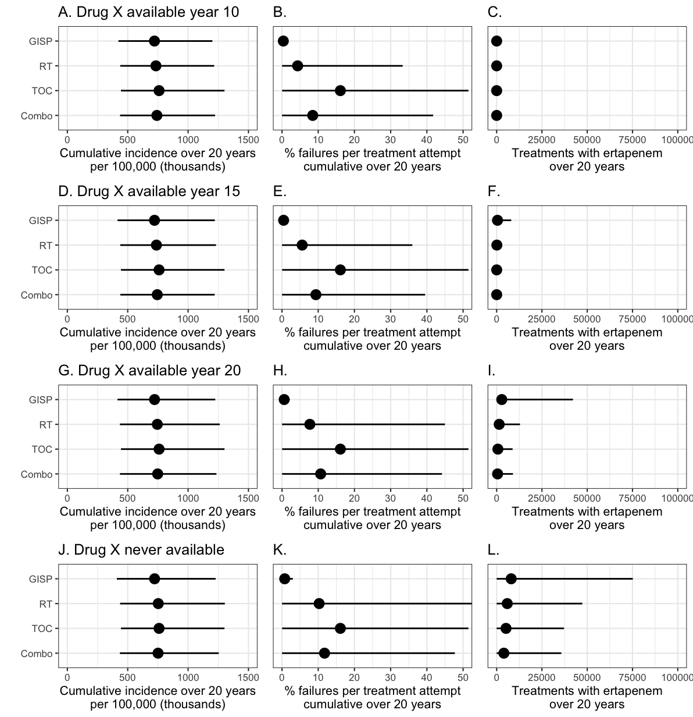
Figure S5. Cumulative outcomes for sensitivity analysis on the availability of drug X. See the caption of Figure 3 for additional information.

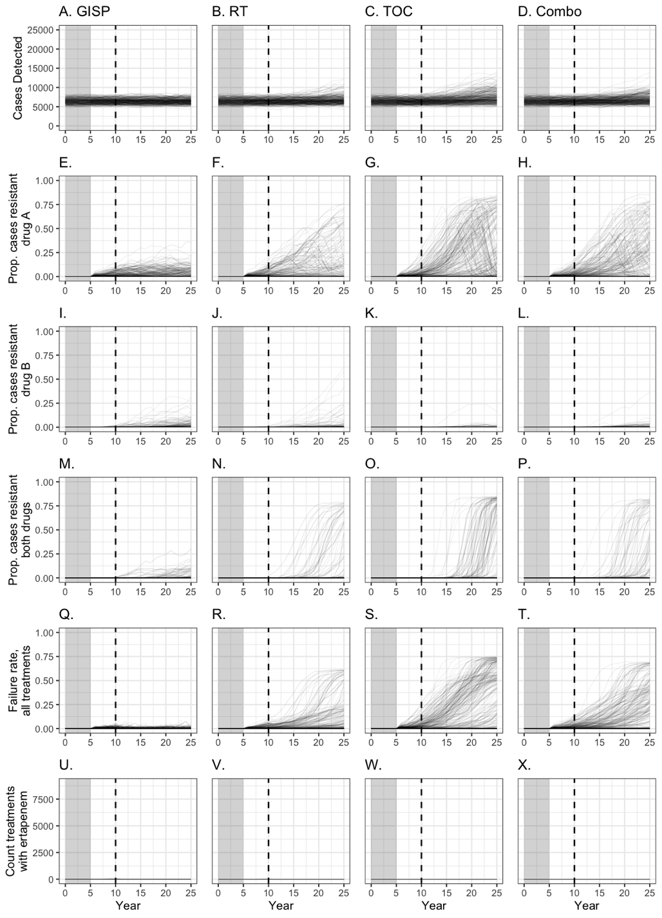
Figure S6. Trends over time in cases detected (first row), prevalence of AMR strains (rows 2-4), treatment failure rate (row 5), and usage of ertapenem, the last-line treatment (row 6) across four strategies for the scenario where drug X become available starting in year 10. See caption of Figure 4 in the main text for more details.
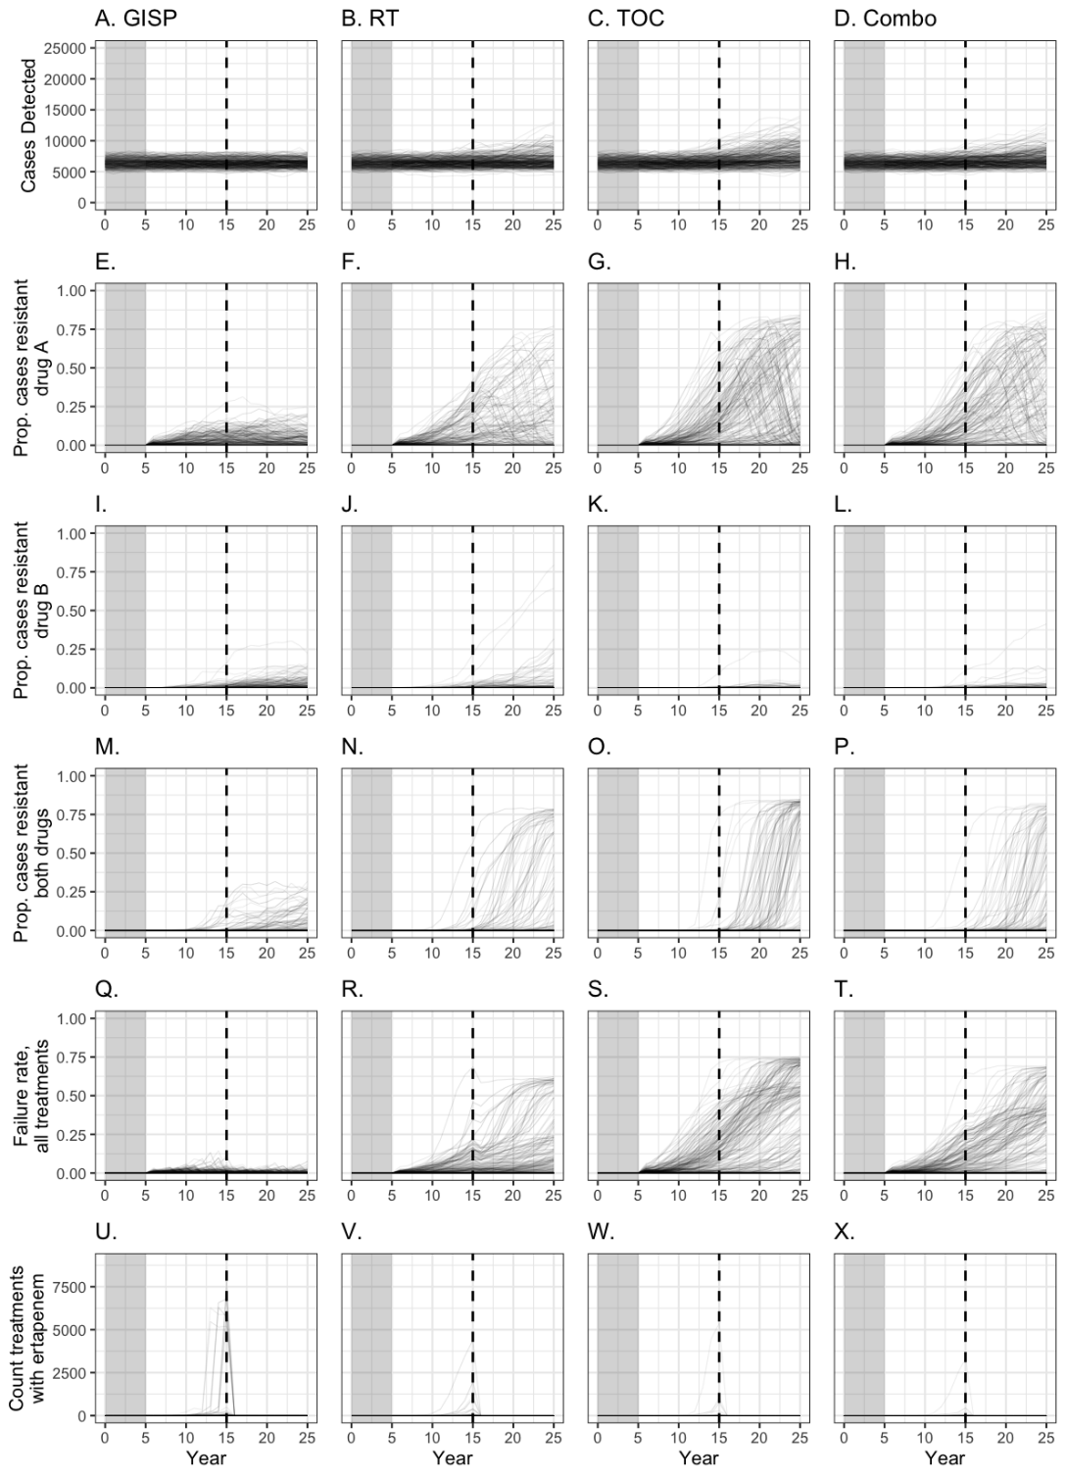
Figure S7. Trends over time in cases detected (first row), prevalence of AMR strains (rows 2-4), treatment failure rate (row 5), and usage of ertapenem, the last-line treatment (row 6) across four strategies under the scenario where drug X become available starting in year 15. See caption of Figure 4 in the main text for more details.
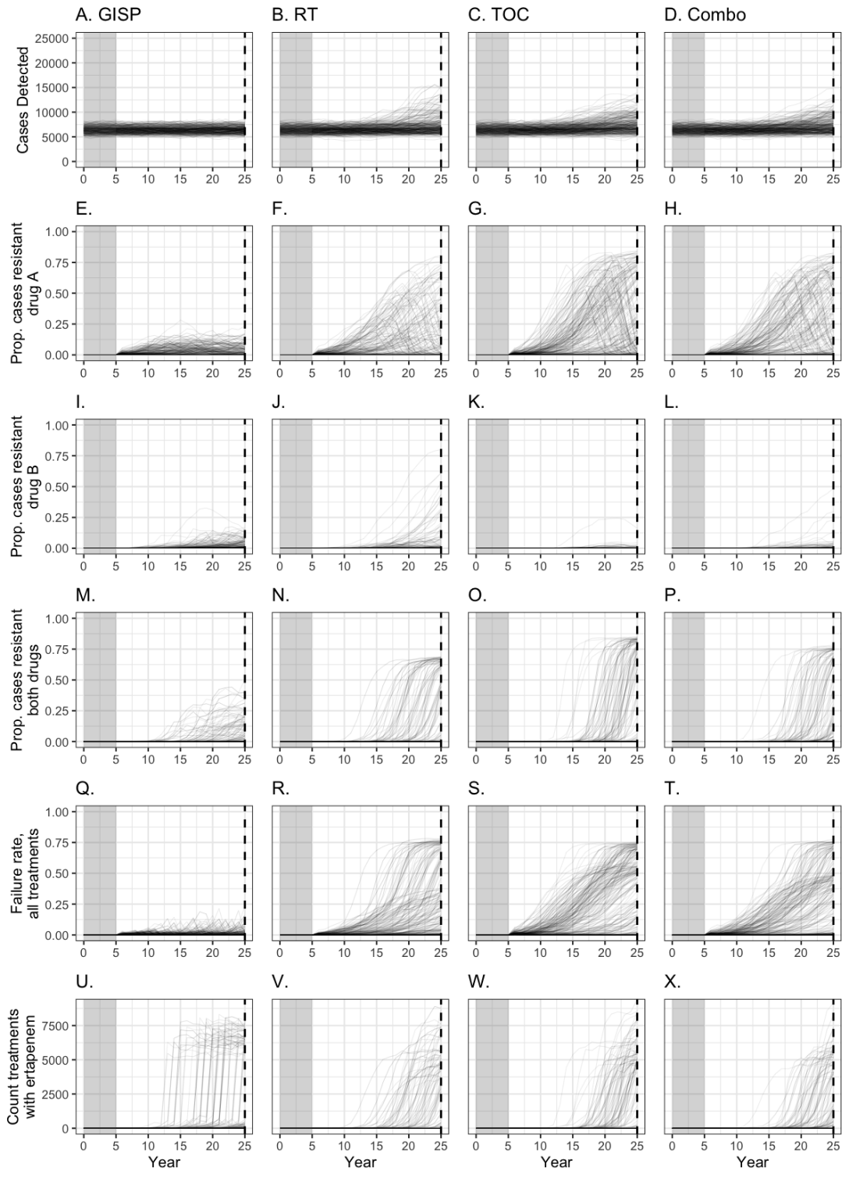
Figure S8. Trends over time in cases detected (first row), prevalence of AMR strains (rows 2-4), treatment failure rate (row 5), and usage of ertapenem, the last-line treatment (row 6) across four strategies under the scenario where drug X never becomes available. See caption of Figure 4 in the main text for more details.

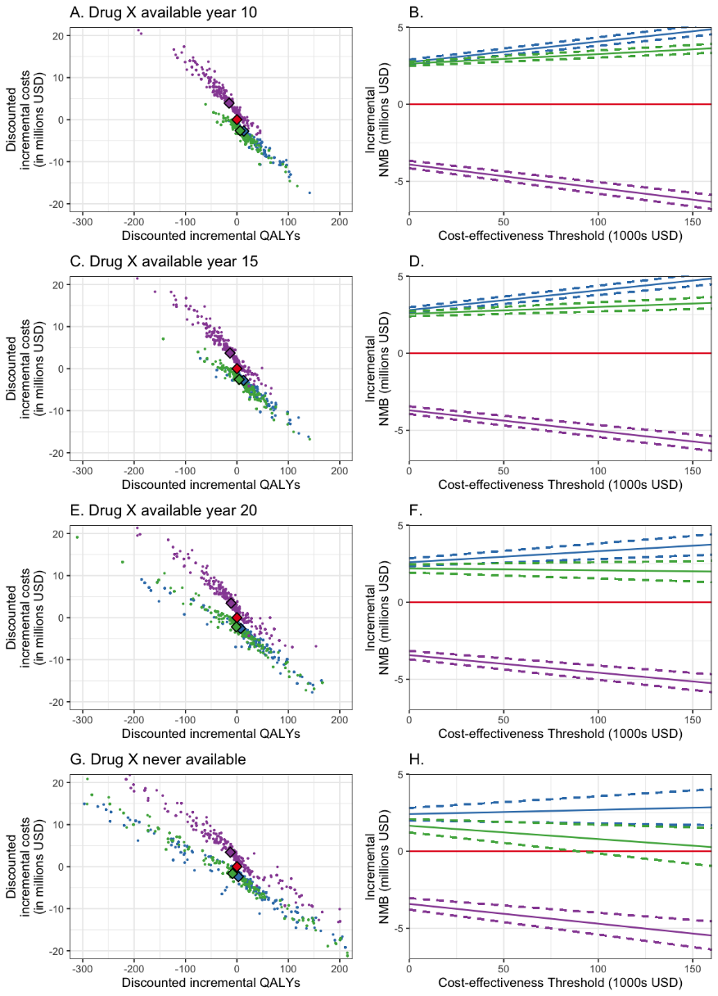
Figure S9. Cost-effectiveness analysis of GISP and three counterfactual strategies under different availability of drug X. Combination of TOC and RT (Combo) is used as the reference strategy. Left column, expected change in cost and expected difference in QALYs; small dots are values from individual trajectories, diamonds are means of each counterfactual. Right column, expected incremental net monetary benefit; solid line represents mean benefit for each counterfactual, dashed lines represent upper and lower bounds of the 95% t confidence intervals. Considered strategies are represented by color. Red =Combo, the reference strategy. Blue = GISP. Green = RT. Purple = TOC.

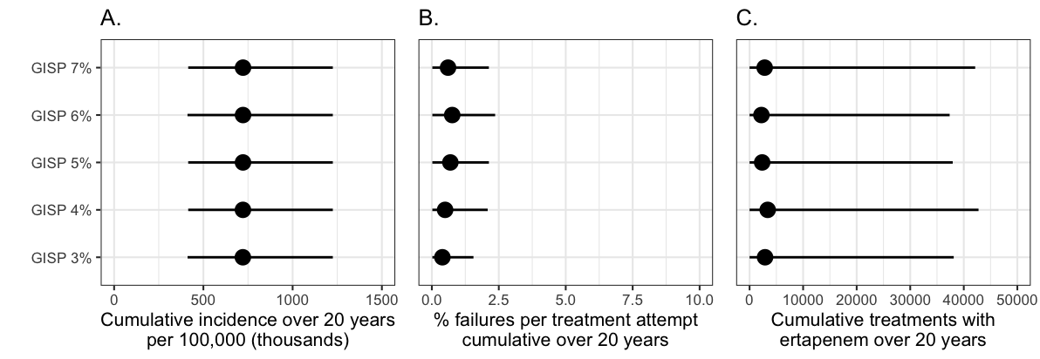
Figure S10. Cumulative outcomes when the switch threshold under GISP was varied between 3% and 7%. Dot indicates the mean model prediction; line corresponds to the 95% uncertainty interval (i.e., extending from the 2.5% quantile to the 97.5% quantile). Failure rate and ertapenem use vary only slightly (B, C), and overall incidence is unaffected (A).
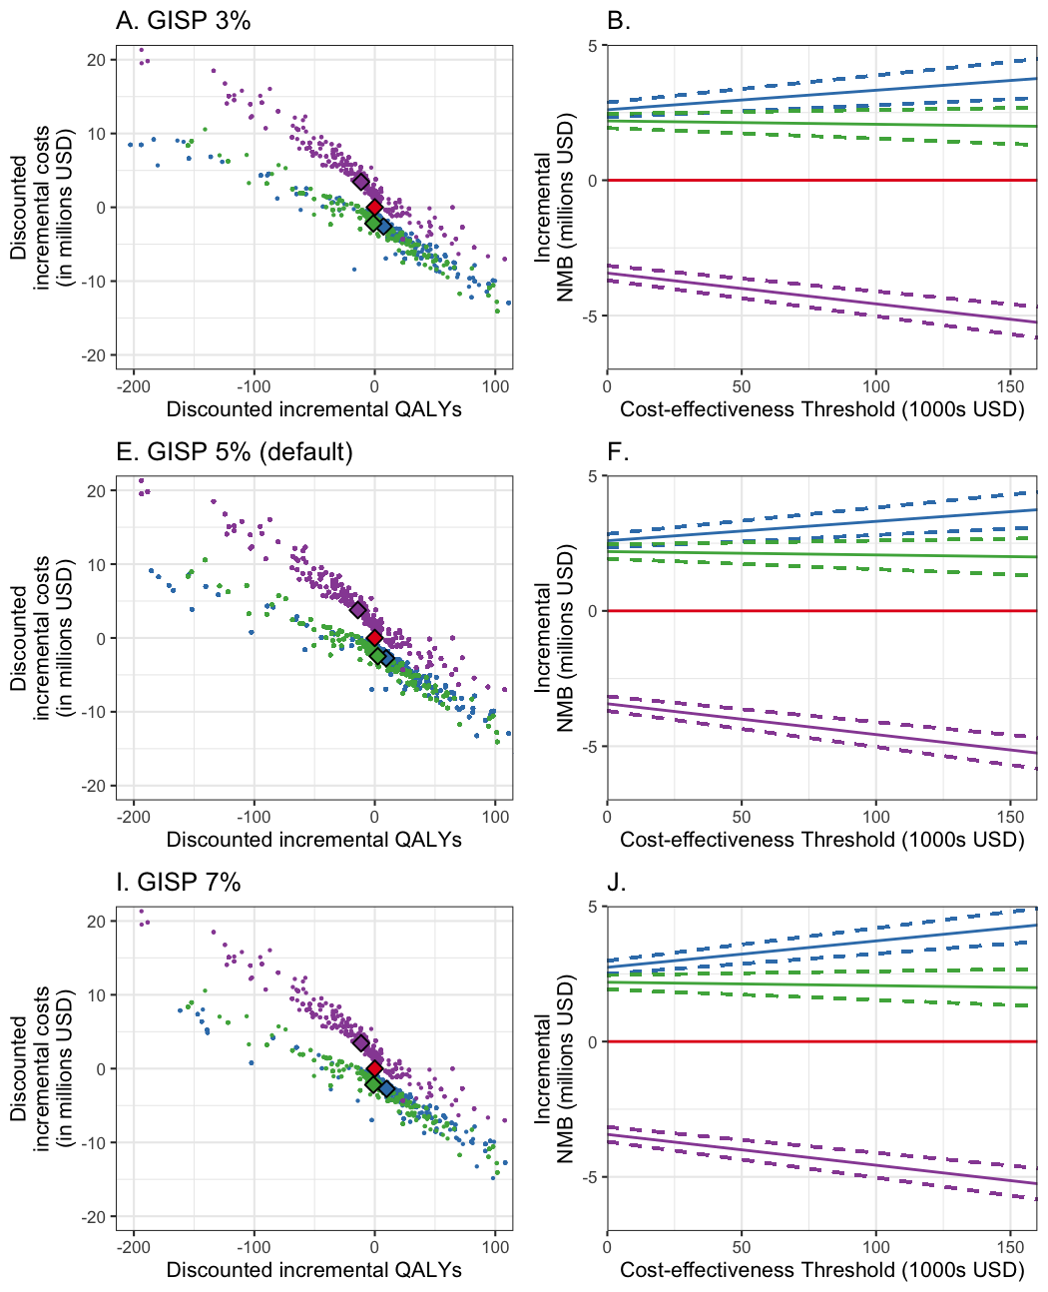
Figure S11. Select cost-effectiveness analysis, where the switch threshold for under GISP was varied between 3% and 7%. Values for other counterfactuals are identical to those presented in the main text. Changing the switch threshold caused minimal change in the relative CEA of the strategies. Red =Combo, the reference strategy. Blue = GISP. Green = RT. Purple = TOC.

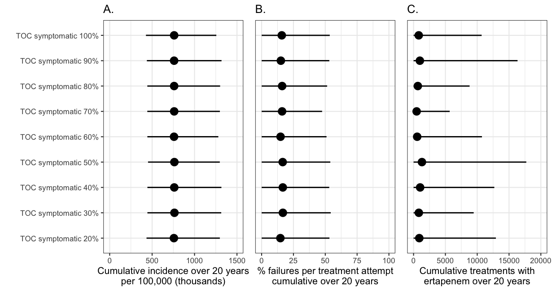
Figure S12. Cumulative outcomes when symptomatic adherence to TOC was varied between 20% and 100%. Dot indicates the mean model prediction; line corresponds to the 95% uncertainty interval (i.e., extending from the 2.5% quantile to the 97.5% quantile).
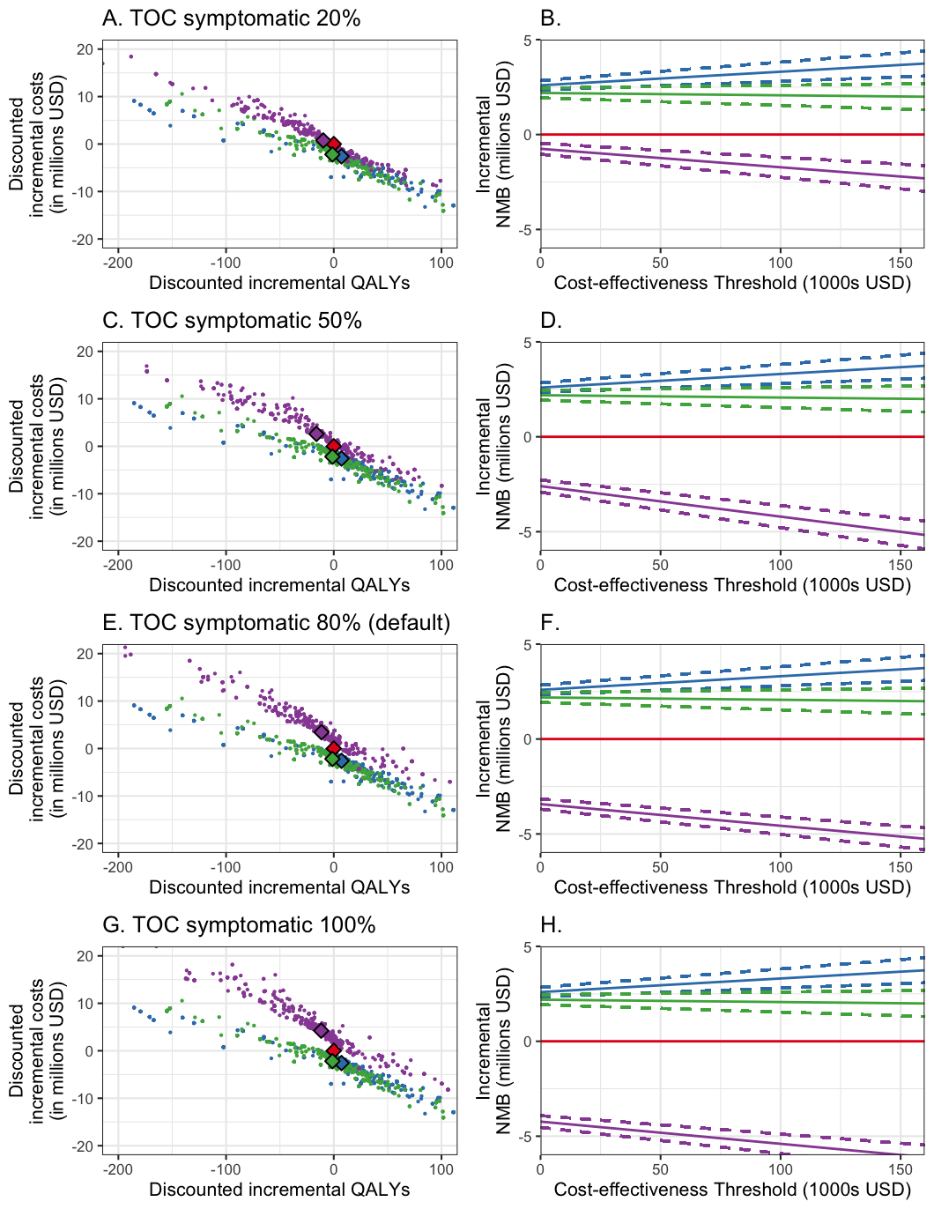
Figure S13. Select cost-effectiveness analysis, where the symptomatic adherence to TOC varied between 20% and 100%. Values for other counterfactuals are identical to those presented in the main text. Changing the TOC adherence of symptomatic cases caused little change in the relative CEA of the strategies. Red =Combo, the reference strategy. Blue = GISP. Green = RT. Purple = TOC.

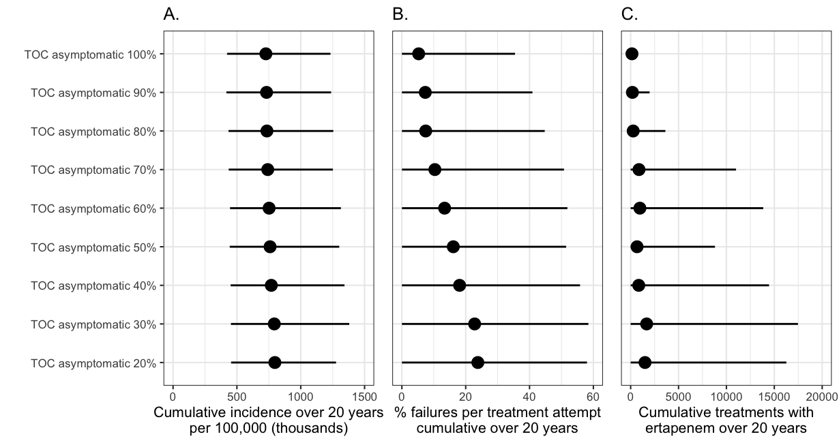
Figure S14.Cumulative outcomes when asymptomatic adherence to TOC was varied between 60% and 100%. Dot indicates the mean model prediction; line corresponds to the 95% uncertainty interval (i.e., extending from the 2.5% quantile to the 97.5% quantile).
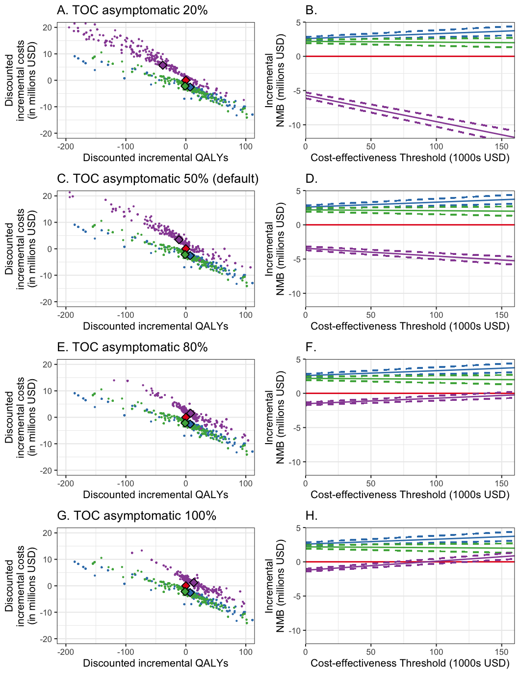
Figure S15. Select cost-effectiveness analysis, where asymptomatic adherence to TOC varied between 20% and 100%. Values for other counterfactuals are identical to those presented in the main text. Changing TOC asymptomatic adherence caused significant change in the relative CEA of this strategy, but was still consistently dominated by GISP. Red =Combo, the reference strategy. Blue = GISP. Green = RT. Purple = TOC.

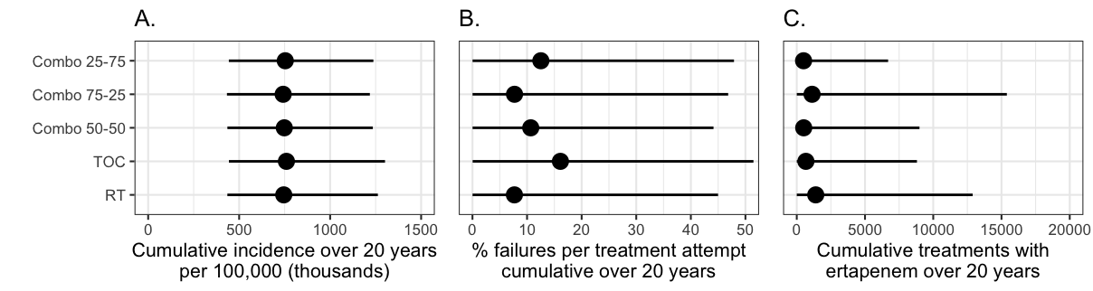
Figure S16. Cumulative outcomes when varying the ratio of cases allocated to either RT or TOC under the Combo strategy. Dot indicates the mean model prediction; line corresponds to the 95% uncertainty interval (i.e., extending from the 2.5% quantile to the 97.5% quantile).

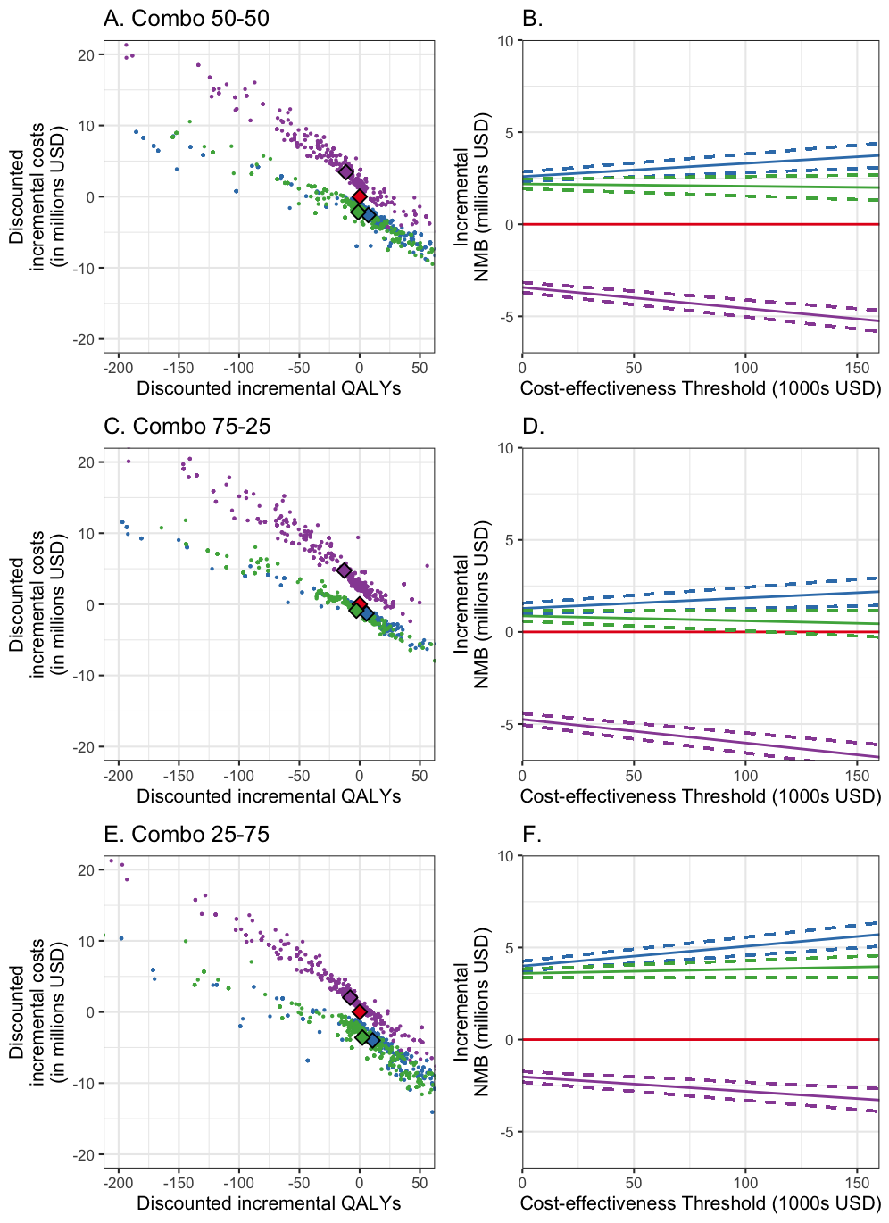
Figure S17. Cost-effectiveness analysis when varying the ratio of cases allocated to either RT or TOC under the Combo strategy.
  - S4.2. References
1. Stinnett AA, Mullahy J. Net health benefits: a new framework for the analysis of uncertainty in cost-effectiveness analysis - PubMed. Medical decision making : an international journal of the Society for Medical Decision Making 1998; 18(2 Suppl).
2. Yaesoubi R, Kunst N. Net Monetary Benefit Lines Augmented with Value-of-Information Measures to Present the Results of Economic Evaluations under Uncertainty - PubMed. Medical Decision Making 2024.
3. Groot Koerkamp B, Hunink M, Stijnen T, Hammitt J, Kuntz K, Weinstein M. Limitations of acceptability curves for presenting uncertainty in cost-effectiveness analysis. Medical decision making 2007; 27(2).

- Rapid Drug Susceptibility Testing (rDST) strategy
  - Introduction
In addition to the four counterfactuals described in the main text, we also considered another hypothetical scenario, the rapid drug susceptibility testing (rDST) strategy (see Figure S18). For this scenario, we assumed that rapid drug susceptibility tests (rDSTs) had been developed for determining susceptibility to drugs A and B, in lieu of surveillance. During the simulation, a portion of detected cases undergo rapid DST (rDST) upon diagnosis and receive the antibiotic that matches the rDST results. We assume imperfect sensitivity and specificity for these hypothetical rapid DSTs, and used Beta distributions to capture the uncertainty in these test characteristics (Table S6).¹ In our base scenario, we assumed that 80% coverage of DSTs, but we varied this coverage amount between 60% and 100% in a sensitivity analysis. For those patients not covered by rDST, treatment follows the same path described for those patients not adhering to TOC (i.e., always try drug A first).
Lastly, we developed a different combination strategy, called mixed testing (MT), where patients were assigned to a mixture of RT, TOC, and rDST. We also varied the probability that each case would be assigned to RT, TOC, or rDST protocol in a sensitivity analysis. For rDST under MT, we assumed that all patients assigned to rDST actually received rDST (i.e., those without access to rDST would have been subsumed into either RT or TOC), and that the sensitivity and specificity of the rDST was the same as under the rDST strategy.

Under rapid drug susceptibility testing (rDST), the treatment pathway depends on adherence. If a case under rDST is selected for non-adherence, it follows “tryDrugA()”. If a case is selected to adhere to the rDST protocol:
- Cost of a drug susceptibility test is added to cumulative costs.
- All infections susceptible to A are treated with drug A and recover. The cost of drug A is added to cumulative costs.
- All infections susceptible to B are treated with drug B and recover. The cost of drug B is added to cumulative costs.
- All infections resistant to both A and B are treated with drug X, if available, or ertapenem, if drug X is not yet available. These infections then recover. The cost of drug X or ertapenem is added to cumulative costs.

  - rDST sensitivity and specificity
Under the rapid drug susceptibility testing (rDST) counterfactual scenario, hypothetical rapid drug susceptibility tests (rDSTs) were used to determine what drug to use to treat a given infection. These rDST tests had sensitivity and specificity controlled by two parameters, DSTsensitivity and DSTspecificity (see Table S6). Sensitivity and specificity of the rDST tests were the same for both drug A and drug B. How the rDST leads to different treatment recommendations based on its sensitivity and specificity is illustrated in Figure S20.
  - Results & Discussion
The rDST scenario resulted in the lowest incidence of AMR gonorrhea and the lowest usage of ertapenem of any of the counterfactuals we tested (Table S7). The rDST scenario cost the most of any strategy tested, but did produce an improvement in QALYs, so it was not dominated by GISP in our cost-effectiveness analysis (Table S8). However, the ICER for this strategy was over $3 million USD, meaning that it was not nearly as cost-effective as GISP. These observations were not sensitive to the level of coverage of rDST (Figure S21, Figure S22).
The MT scenario was very similar to the Combo scenario presented in the main text. GISP was similarly cost-saving when compared to MT as it was when compared to Combo. Varying the probabilities of RT, TOC, and rDST under MT did not change this observation (Figure S23, Figure S24).
It is worth highlighting that rDST was not projected to rely on usage of drug X or ertapenem. Therefore, this hypothetical individualized strategies might be preferable in circumstances where ertapenem is scarce or cost-prohibitive. However, both rDST and MT do rely on the usage of rapid drug susceptibility tests (rDSTs), which do not currently exist for gonorrhea for ceftriaxone, zoliflodacin, or gepotidacin. For scenarios which involve rDST, we did not represent the costs which would need to be invested into developing rapid drug susceptibility testing technology and increasing production capacity. Accounting for this expenditure, GISP is likely even more cost-saving relative to MT than we estimated, and the ICER of rDST is even higher than we estimated. However, without a clear way of estimating the costs of developing and deploying rDSTs for gonorrhea, we chose to exclude these costs from our model.
From this analysis we conclude that, even if an rDST for current and future gonorrhea treatments was available, rapid drug susceptibility testing would not be a more cost-effective strategy than GISP, under current assumptions regarding the cost and performance of rDST.

Table S6. Sensitivity and specificity parameters associated with the rapid drug susceptibility testing (rDST) under the rDST scenario.
parameter | Beta Distribution | Ref
DSTsensitivity: the sensitivity of rDST, defined as the probability of correctly identifying that an infection is resistant to a drug. For each test, a random value from a uniform distribution (0.0-1.0) is compared to the parameter value to determine whether the test returns a true positive or a false negative. | Mean = 0.95  SD = 0.01 | ²
DSTspecificity: the specificity of rDST, defined as the probability of correctly identifying that an infection is susceptible to a drug. For each test, a random value from a uniform distribution (0.0-1.0) is compared to the parameter value to determine whether the test returns a true negative or a false positive. | Mean = 0.97  SD = 0.005 | ²
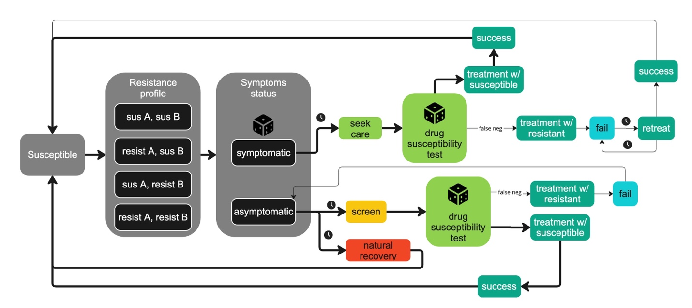
Figure S18. Model diagram for rapid drug susceptibility testing (rDST) counterfactual. See Figure S1 caption for symbol explanations. “false neg” indicates when the result of the rapid drug susceptibility test returns a false negative result, causing the administration of a treatment which the infection is resistant. For cases without coverage for rDST, drug A is always first-line.

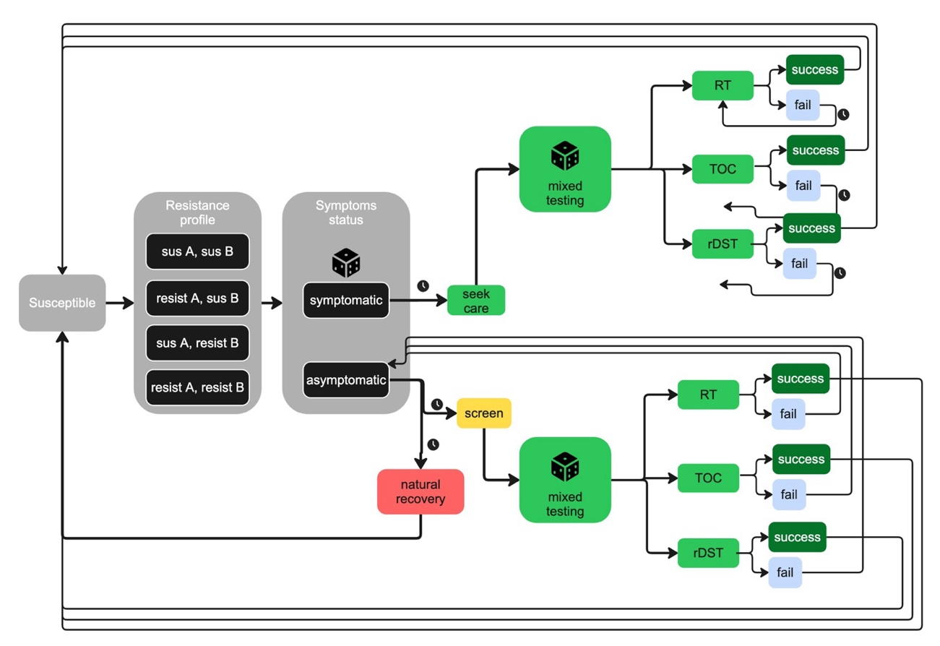
Figure S19. Model diagram for mixed testing (MT) counterfactual. See Figure S1 caption for symbol explanations. After an indiv is randomly assigned to RT, TOC, or DST, treatment, failure/success, and retreatment follow the same pathways described in Figures S1, S2, and S3, which are simplified away here for legibility.

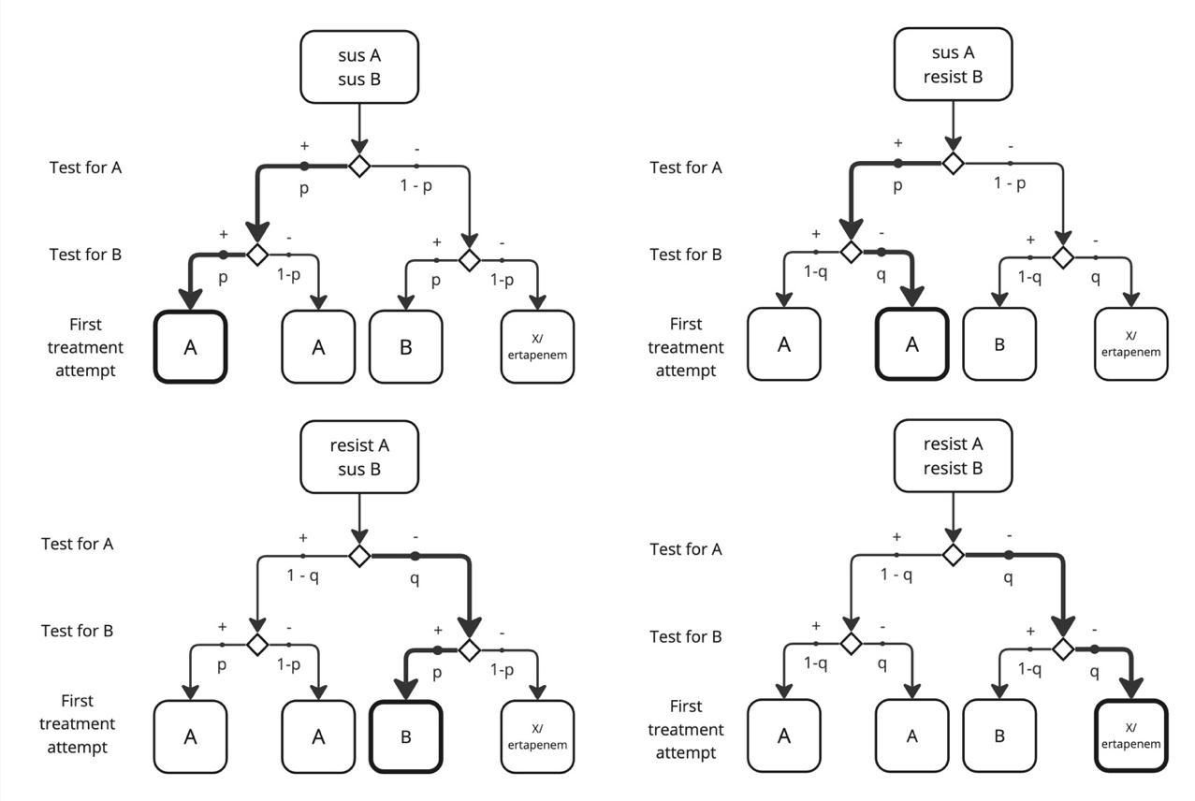
Figure S20. Modeling the impact of rDST on the recommendation for the treatment of a given strain of infection, depending on the sensitivity and specificity of the test. p = sensitivity, q = specificity. The thicker arrows and thicker-outlined box indicate what outcome is most likely, given the prior distributions for sensitivity and specificity (Table S5).

Table S7. Cumulative results of gonorrhea burden under five counterfactual strategies, beginning at the end of the calibration period (year 5). MT (mixed testing) counterfactual includes RT, TOC, and rDST possibilities with probabilities of 45-45-10. Presented are the means of 380 unique trajectories; in parentheses are the 95% uncertainty intervals, derived from the 2.5% and 97.5% quantiles of the simulated data. Cumulative incidence of gonorrhea includes both detected and undetected infections. Cumulative incidences of AMR gonorrhea includes both detected and undetected infections of all resistant strains, combined. Treatment failure rate is calculated as the number of treatment failures divided by the number of all treatment attempts.
 | GISP | RT | TOC | rDST | MT
Cumulative incidence of gonorrhea | 722,096  (415,122, 1,225,184) | 744,987  (435,196, 1,262,317) | 759,672  (443,702, 1,301,533) | 722,145  (413,813, 1,198,869) | 744,260  (441,862, 1,270,836)
Cumulative incidence of AMR gonorrhea (A, B, and A+B strains) | 28,756  (151, 143,318) | 99,273  (112, 592,069) | 155,983  (157, 745,978) | 18,738  (104, 155,223) | 105,048  (89, 579,540)
Treatment failure rate | 0.60%  (0.02, 2.13) | 7.68%  (0.01, 44.99) | 16.11%  (0.03, 51.47) | 0.60%  (0.01, 3.48) | 8.50%  (0.01, 40.68)
Total count treatments with ertapenem | 2,818  (0, 42,129) | 1,390  (0, 12,890) | 668  (0, 8,805) | 1,120  (37, 293) | 817  (3, 11,566)

Table S8. Cost-effectiveness table to select among counterfactuals considered, including hypothetical scenarios with rapid drug susceptibility testing (rDST). MT counterfactual includes RT, TOC, and rDST at probabilities of 45-45-10. Total QALYs lost includes QALY loss attributable to gonorrhea symptoms, sequelae, and side effects.
Alternative | Cost (millions USD) | Effect: Total QALYs lost | Incremental Cost (millions USD) | Incremental Effect (QALYs gained) | ICER (millions USD)
MT | 22.50  (17.35, 35.70) | 227.2  (144.9, 420.3) | - | - | -
GISP | 18.28  (14.25, 28.46) | 222.3  (147.9, 389.3) | -4.22  (-14.72, 5.48) | 4.9  (-150.1, 122.0) | Cost-saving
RT | 18.68  (14.07, 29.36) | 230.7  (147.2, 400.8) | - | - | Dominated
TOC | 20.87  (15.56, 33.83) | 229.4  (145.0, 367.8) | - | - | Dominated
rDST | 34.02  (28.13, 41.75) | 210.3  (145.8, 282.9) | 15.74  (5.87, 20.10) | 11.9  (-7.4, 188.1) | $1.97  (-98.31, 61.33)

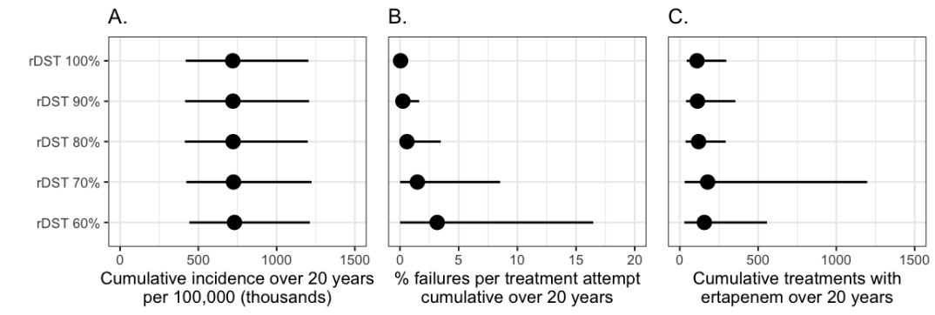
Figure S21. Cumulative outcomes when coverage of DST was varied between 60% and 100%. Dot indicates the mean model prediction; line corresponds to the 95% uncertainty interval (i.e., extending from the 2.5% quantile to the 97.5% quantile).
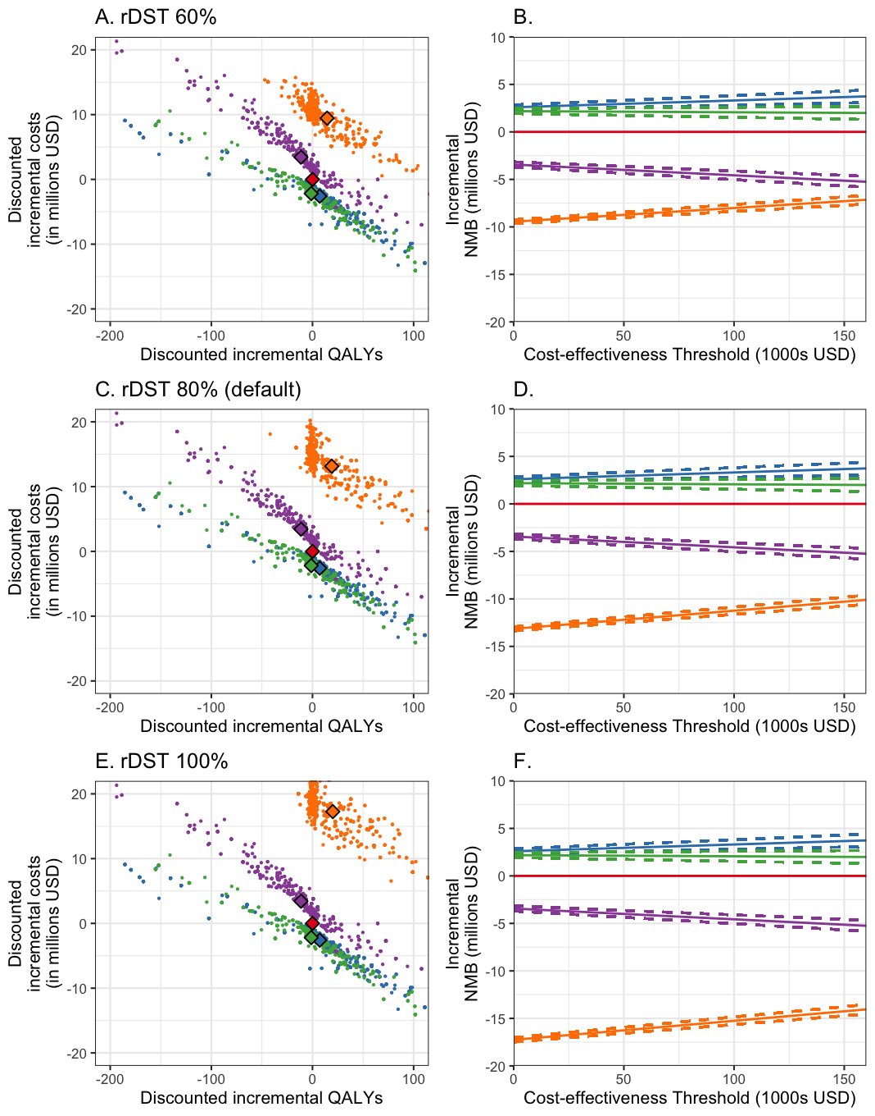
Figure S22. Select cost-effectiveness analysis, where the coverage of DST was varied between 60% and 100%. Values for other counterfactuals are identical to those presented in the main text. Changing DST coverage caused minimal change in the relative CEA of the strategies. Red =MT, the reference strategy. Blue = GISP. Green = RT. Purple = TOC. Orange = DST

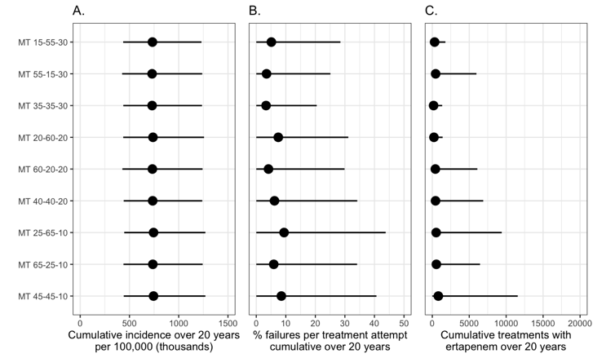
Figure S23. Cumulative outcomes under the mixed testing (MT) strategy when varying the probabilities that a case will be assigned to RT, TOC, or DST protocols. Each scenario has a label with three numbers, corresponding the percentage chance of being assigned to RT, TOC, and DST protocols respectively. Dot indicates the mean model prediction; line corresponds to the 95% uncertainty interval (i.e., extending from the 2.5% quantile to the 97.5% quantile). Asterisk denotes the default scenario presented in Tables S7 and S8.
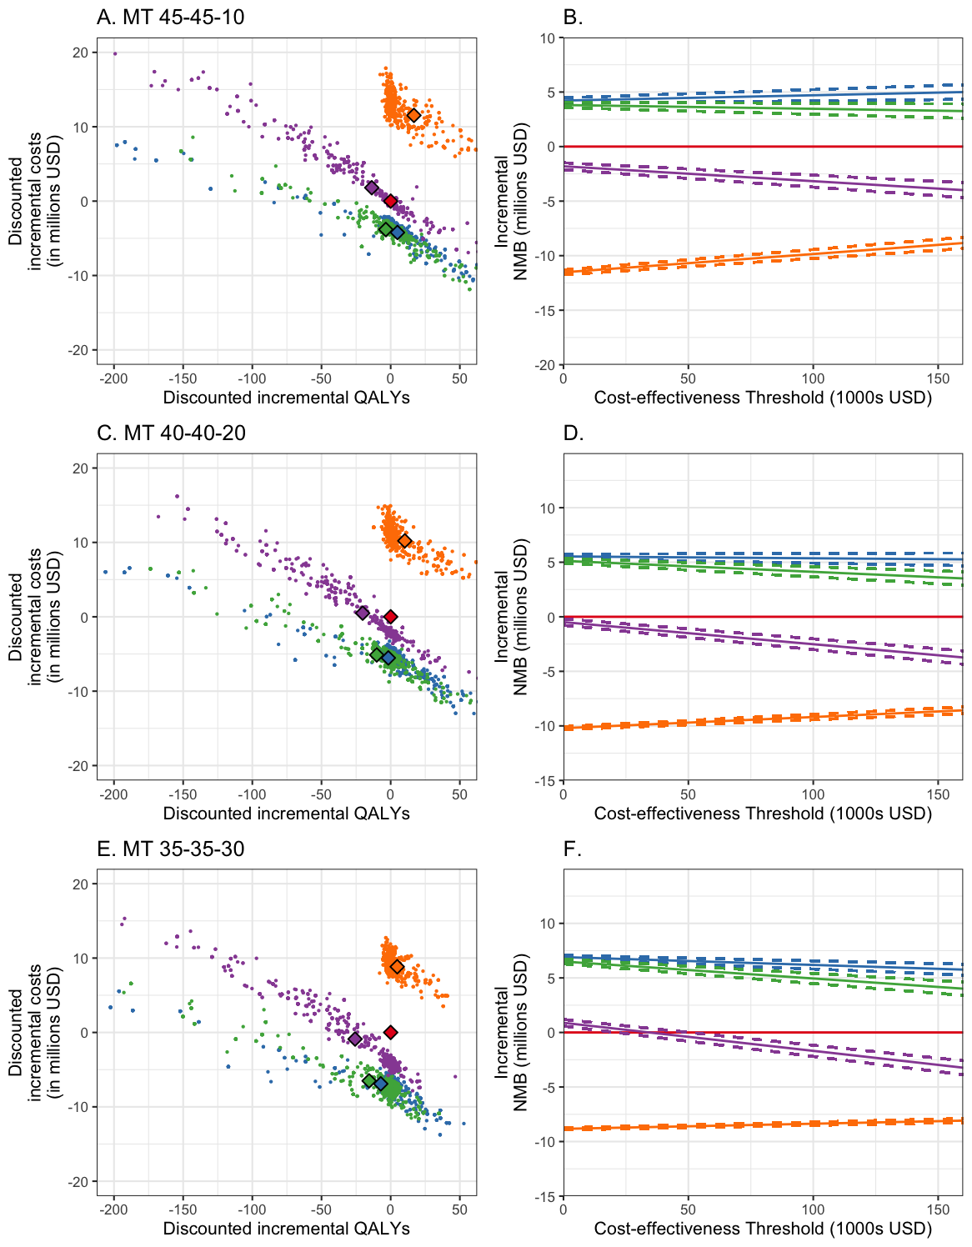
Figure S24. Select cost-effectiveness analysis when varying the probabilities that a case will be assigned to RT, TOC, or DST protocols under the MT strategy. Each scenario has a label with three numbers, corresponding the percentage chance of being assigned to RT, TOC, and DST protocols respectively. Red = MT, the reference strategy. Blue = GISP. Green = RT. Purple = TOC. Orange = DST.

  - References
1. Yaesoubi R, Xi Q, Hsu K, et al. The Impact of Rapid Drug Susceptibility Tests on Gonorrhea Burden and the Life Span of Antibiotic Treatments: A Modeling Study Among Men Who Have Sex With Men in the United States. American Journal of Epidemiology 2024; 193(1).
2. Gaydos CA, Melendez JH. Point-by-Point Progress: Gonorrhea Point of Care Tests. Expert Review of Molecular Diagnostics 2020; 20(8).

- Screening Heterogeneity
  - Scenario description
Calibrating our model consistently resulted in posterior distributions for screening interval in the range of 1.5 to 3.0 years, indicating the screening was infrequent and rare. However, this did not capture the considerable heterogeneity that there is likely to be in screening frequency in real populations. In particular, MSM on pre-exposure prophylaxis for HIV (PrEP) are recommended to be tested for STIs, including gonorrhea, every 3 months,¹ but data is lacking on the actual frequency of STI screening for MSM, including those on PrEP or antiretroviral therapy (ART). Therefore, we wanted to test whether our results were robust to increasing screening heterogeneity, according to the assumption that a subset of the MSM population is screened more frequently than the general MSM population.
For simplicity, we assumed that our high-activity group was being screened more frequently than the low-activity group. We modified the model so that the mean screening interval of the high-activity group was the parameter ScreenIntervalMSMHigh; our prior distribution for this parameter was 0.1 to 1.5 years. ScreenIntervalMSMHigh was multiplied by another parameter, ScreenIntervalMSMRatio, to produce the mean screening interval of the low-activity group. The prior distribution of ScreenIntervalMSMRatio was 1.0-10.0; this meant that the low-activity screening interval was always equal to or greater than the high-activity screening interval. Once the mean screening intervals were calculated for both activity groups, each individual in the simulation was assigned a full schedule of both low-activity and high-activity screenings. (This was necessary since individuals were allowed to move between the activity groups.) Then, each individual would be screened according to their schedule for the activity group that they were currently in; to reduce computational load, this only occurred when individuals were actually infectious.
Introducing screening heterogeneity complicated model calibration. We had to adjust the prior ranges for many parameters in order to generate more than a handful of possible trajectories (Figure S 25). Eventually, 88 unique trajectories were resampled (Figure S 26), and we used these to compare the counterfactuals.
Overall, the results with screening heterogeneity in the model are similar to our base analysis (Figure S 27). All scenarios resulted in similar gonorrhea incidence, but GISP resulted in markedly lower rate of treatment failure. GISP had a slightly greater usage of ertapenem, the last-line antibiotic treatment, than the other scenarios did. Differences among the strategies become even more stark when considering gonorrhea burden and strain prevalence over time (Figure S 28). The GISP scenario showed much lower prevalence of AMR gonorrhea strains, while the other scenarios displayed rising AMR strains and treatment failure over time.

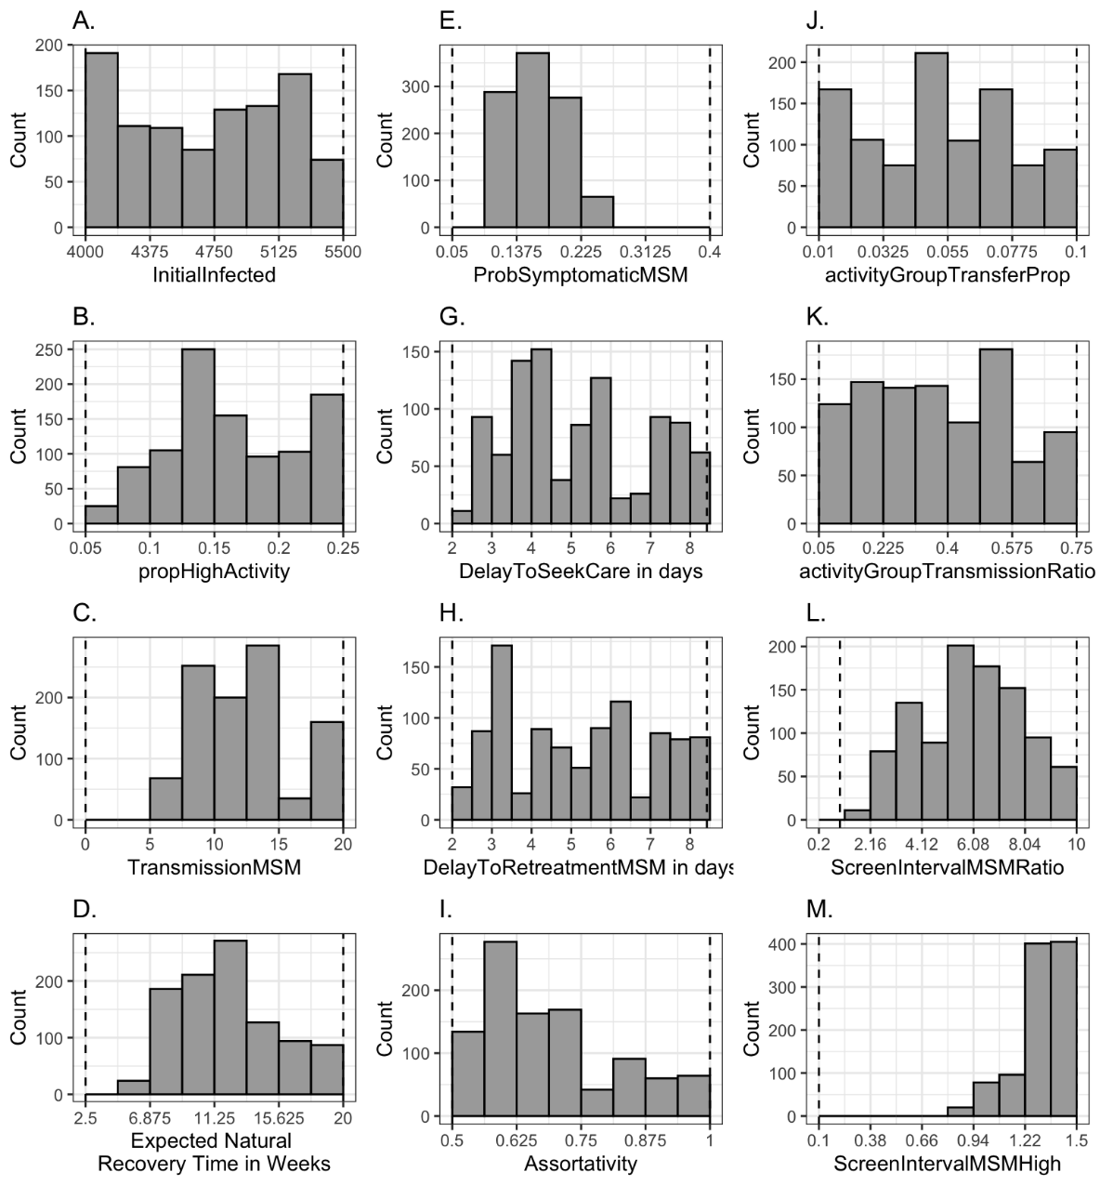
Figure S 25. Parameter estimates, based on resampling with replacement based on trajectory probability weights (see §S1.3). Dashed vertical lines in panels indicate the ranges of the prior distributions for each parameter.

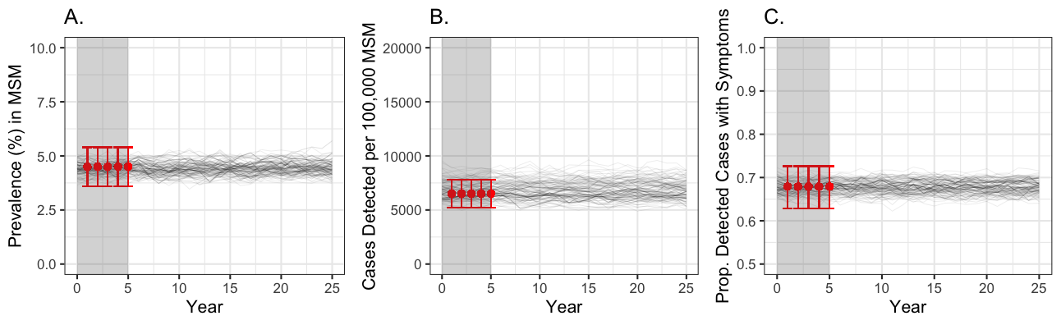
Figure S 26. Comparing calibration targets (shown in red) with simulated trajectories without AMR for 25 years, with screening heterogeneity. A) prevalence of infection. B) incidence of cases detected per 100,000. C) proportion of detected cases that present with symptoms. Darkness of the black lines relates to how frequently that trajectory was resampled, according to its likelihood when compared to the calibration target. Red dots indicate the observed value, and the red error bars indicate the confidence interval (see text for data sources). The grey region represents the calibration period.

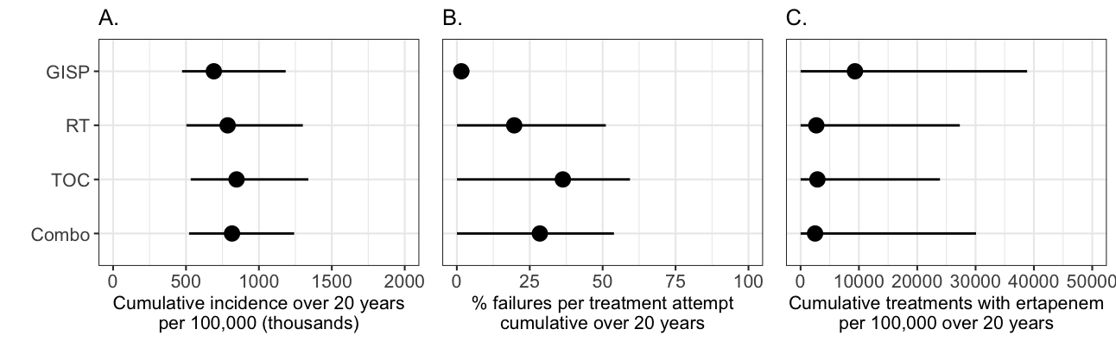
Figure S 27. Cumulative outcomes for the four mitigation strategies, beginning at the end of the calibration period and continuing to the end of each simulation, with screening heterogeneity. Dot indicates the mean model prediction; line corresponds to the 95% uncertainty interval (i.e., extending from the 2.5% quantile to the 97.5% quantile). A) total disease incidence, including both detected and undetected cases. B) percentage of treatment attempts that resulted in treatment failure for drugs A, B, and X. C) count of treatments with ertapenem.
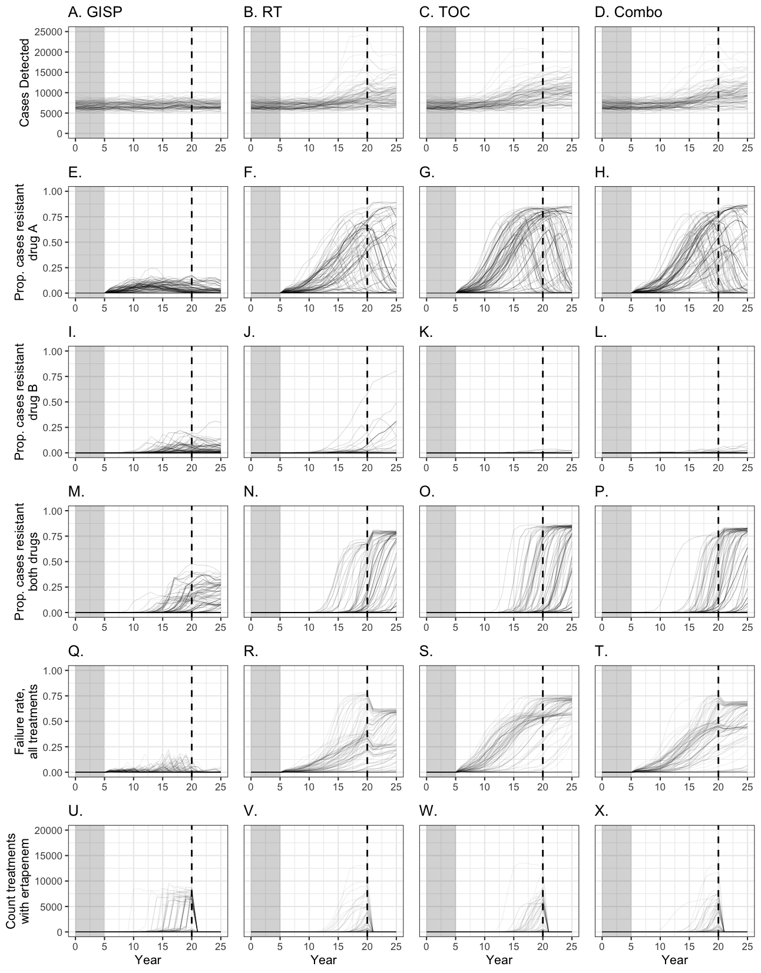
Figure S 28
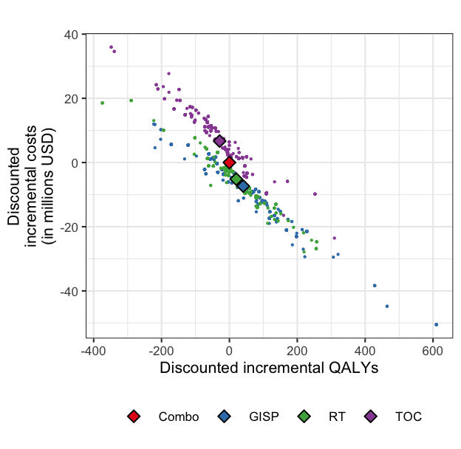
Figure S 29

Table S 9. Mean cumulative results (uncertainty intervals) of four measures of gonorrhea burden, with screening heterogeneity: gonorrhea incidence, antimicrobial-resistant (AMR) gonorrhea incidence, treatment failure rate, and total count of treatments with ertapenem
 | GISP* | Randomized  Treatment (RT)† | Test of Cure  (TOC)‡ | Combo§
Cumulative incidence of gonorrhea over 20 years | 690,898  (473,044, 1,183,579) | 785,666  (502,500, 1,301,123) | 846,594  (532,324, 1,339,187) | 815,611  (521,133, 1,241,721)
Cumulative incidence of AMR gonorrhea over 20 years | 72,705  (296,  175,509) | 291,120  (1,304,  766,662) | 429,742  (1,066, 1,036,063) | 359,163  (282,  805,461)
Treatment failure rate | 1.52%  (0.03, 4.27) | 19.67%  (0.06, 51.11) | 36.35%  (0.04, 59.37) | 28.46%  (0.03, 53.87)
Total count treatments with ertapenem | 9,322  (0, 38,837) | 2,695  (0, 27,301) | 2,880  (0, 23,895) | 2,481  (0, 30,078)
Refer to Table 1 in the main text for legend.

Table S 10. Cost-effectiveness results: Cost, number of quality-adjusted life years (QALYs), and incremental cost-effectiveness ratios for four strategies, with screening heterogeneity
Alternative | Cost (millions USD) | QALYs¶ lost | ICER#
GISP* | 20.5  (16.0, 31.1) | 255.3  (157.9, 404.1) | Cost-saving
RT† | 22.6  (15.6, 39.1) | 275.8  (181.1, 472.4) | Dominated
Combo‡ (Reference) | 27.8  (17.7, 43.2) | 296.1  (205.7, 450.8) | Dominated
TOC§ | 34.5  (19.7, 56.9) | 324.8  (204.0, 562.4) | Dominated
Refer to Table 2 in the main text for legend.

  - References
1. Workowski KA, Bachmann LH, Chan PA, et al. Sexually Transmitted Infections Treatment Guidelines, 2021. MMWR Recommendations and Reports 2021; 70(4).

- Fitness Cost Analysis
  - Methods
Only limited data is available on the fitness costs of antimicrobiral resistant (AMR) strains of gonorrhea.
  - Results and Discussion
  - References

Future drug costs are unknown. We assumed that future drug costs would be the same as the cost of drug A, which was based on ceftriaxone. Assuming a higher cost for drug B and/or drug X may affect the relative cost of GISP, since on average, GISP used less drug B than other strategies and slightly more drug X than other strategies. However, we were unable to examine cost counterfactuals for this study.
We did not assume any side effects for drugs A, B, and X. Including side effects for these drugs would likely make the GISP strategy relatively more favorable than we estimated, because retreatment was less common under GISP than the other strategies. Therefore, since more drug doses were administered in the RT, TOC, and Combo scenarios, side effects would have led to more QALYs lost in these scenarios.

